Creation of application for School management using Salesforce

**NAAN MUDHALVAN PROJECT REPORT**

Submitted by

| **ANIYHA T** | **(au611420104006)** |
| --- | --- |
| **DEEPIKA B** | **(au611420104013)** |
| **LAKSHMI M** | **(au61142010431)** |
| **SARASWATHI K** | **(au611420104071)** |

**SANDHIYA C (au611420104067)**

*In partial fulfillment of the award of the degree* of

**BACHELOR OF ENGINEERING**

*in*

**COMPUTER SCIENCE AND ENGINEERING**

**MAHENDRA ENGINEERING COLLEGE FOR WOMEN , NAMAKKAL- 636 003**

**ANNA UNIVERSITY :: CHENNAI 600 025**

# BONAFIDE CERTIFICATE

Certified that this project report **“Creation of application for school management ”** is the bonafide work of **“Anitha T (au611420104006), Deepika B(au611420104013), Lakshmi M (au611420104031), Saraswathi K (au611420104071),Sandhiya C(au611420104067)”** who carried out the project work under my supervision.

| **SIGNATURE** | **SIGNATURE** |
| --- | --- |
| **HEAD OF THE DEPARTMENT**  **Prof. M,MANIMEGALAI, M.E.,** | **PROJECT SUPERVISOR**  **Mr. N. KOWSALYA, M.E.,** |
| Assistant Professor, Department of CSE,  Mahendra Engineering College for women, Namakkal- 636003. | Assistant Professor, Department of CSE,  Mahendra Engineering College for women, Namakkal- 636003. |
| **SPOC** | **HEAD OF THE DEPARTMENT** |

# TABLE OF CONTENTS

| **Chapter**  **No** | **Title** | **Page No** |
| --- | --- | --- |
| 1. | **LIST OF FIGURES**  **PROJECT SPECIFICATION**   * 1. Project Goal   2. Project Scope   3. Problem Statement Definition   4. Empathy Map Canvas   5. Proposed Solution   6. Functional & Technical Requirements   7. Project Road Map | **5**  **6**  6  7  8  8  10  11  12 |
| 2. | **PREPARATION DATA MODELING**   * 1. Salesforce Developer Org   2. Object Creation   3. Fields and Relationship   4. Page Layouts   5. The Lightning App | **14**  14  16  18  20  21 |
| 3. | **USERS & DATA SECURITY**   * 1. Profile   2. Setup Roles   3. Users   4. User Adoption & Approval | **24**  24  30  32  34 |
| 4. | **AUTOMATION**   * 1. Flow | **41**  41 |
| 5. | **REPORTS & DASHBOARD**   * 1. Reports   2. Dashboard | **43**  43  47 |
| 6. | **CONCLUSION** | **49** |
| 7. | **Project Demonstration**  GitHub & Project Video Demo Link | **50** |

**LIST OF FIGURES**

| **Figure No** | **Name of Figure** | **Page No** |
| --- | --- | --- |
| 1.7.1 | Data Flow Diagram | 12 |
| 1.7.2 | Technical Architecture | 13 |

* 1. **Project Goal**

# CHAPTER-1 PROJECT SPECIFICATION

The goal of school administration is to create an environment in which all students can demonstrate continuous academic improvement. The superintendent must possess leadership qualities which motivate all staff members to improve the educational program and to attain the board's goals and objectives.

* Operational Efficiency: School is one of the basic necessities of Human beings School is like heaven and the teacher is god for the students.
* Customer Engagement: School management is a very wide field and this work needs a lot of personnel to run this management as any other organization.
* Growth: The first objective of this system is to maintain the data of all the student and teacher in database. It maintains the personal record as well as the academic record of the student. It maintains student fee record and dues record. Teacher personal record and salary record are also store in the software
* Data Management: A school management system is a software application that is designed to streamline various administrative tasks within a school.
* Automation: Introduce automation through triggers, flows, and approval processes to reduce manual tasks and improve accuracy in coupon generation and record keeping.
  1. **Project Scope**

The scope of the School management Application project is comprehensive and covers various aspects of students. This project encompasses the following key components:

1. Custom Object Creation: Anything done to improve the quality of education at any stage may be ranging from the supply of material, human and financial resources to the highest cultural or academic needs-comes.
2. Application used: Scope is the set of features, functions, and requirements that the web app must deliver to meet the needs and expectations of the stakeholders.
3. User Profiles and Roles: The project scope is the total amount of work that needs to be done to complete a project. To define it, project managers must break down the project into the tasks and deliverables.
4. Automation: Implementing automation through triggers, flows, and approval processes to automate processes like coupon generation based on employee types, data validation, and record updates.
5. Reports and Dashboards: Developing various report types, including tabular, summary, and matrix reports, to provide insights into customer data, product sales, and financial performance. Creating dashboards for data visualization.
6. Data Modeling: Designing the data model with relationships between objects to enable efficient data management, allowing the creation of customer records, order details, and coupon management.
7. Security and Access Control: Ensuring data security and access control through user profiles, roles, and sharing rules to safeguard sensitive information.
   1. **Problem Statement Definition**

| **Problem for** | **Trying to** | **But** | **Which makes** |
| --- | --- | --- | --- |
| **Students** | Poor communication between parents and school staff is a major problem that contributes to the overall ineffective management of schools. | When parents and teachers are not able to communicate effectively, it can have a negative impact on the entire school community & learning. | This makes me feel overwhelmed and hinders our ability to provide a seamless student experience. |

* 1. **Empathy Map Canvas**

An empathy map is a simple, easy-to-digest visual that captures knowledge about a user’s behavior and attitudes.

It is a useful tool to helps teams better understand their users. Creating an effective solution requires understanding the true problem and the person who is experiencing it.

The exercise of creating the map helps participants consider things from the user’s perspective along with his or her goals and challenges.

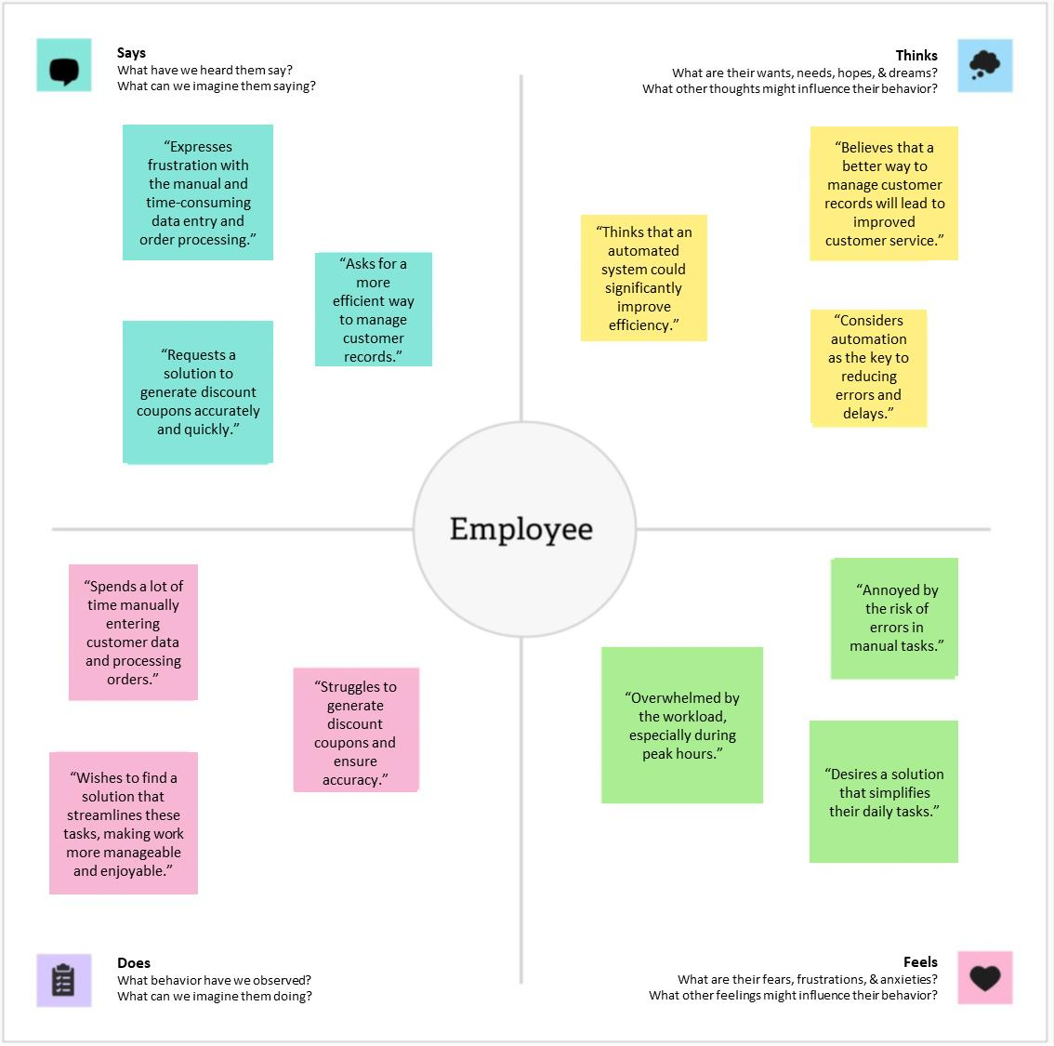

* 1. **Proposed Solution**

| **S. No** | **Parameter** | **Description** |
| --- | --- | --- |
| 1. | Problem Statement | The problem to be solved is the manual and time-school management of customer records, order processing, and discount coupon generation, leading to  inefficiencies and the risk of errors. |
| 2. | Idea / Solution Description | The proposed solution is to create a Salesforce-based School Management system. This system will include custom objects for managing customer records, consultants, retailers, and other employees. Automation tools like triggers and flows will streamline data entry, order processing, and coupon generation. The solution will also provide comprehensive reports and dashboards for insights and  decision-making. |
| 3. | Novelty / Uniqueness | The uniqueness of this solution lies in its customized implementation using Salesforce. The automation of routine tasks, such as coupon generation based on employee roles, is novel and addresses the  specific needs of cosmetics stores. |
| 4. | Social Impact Satisfaction | The solution is expected to significantly improve customer satisfaction by reducing processing times, minimizing errors, and enhancing the overall shopping experience. It will also lead to improved data management, enabling better customer engagement and personalized services. This project contributes to the efficient management of cosmetics stores, potentially impacting the business's social  and financial aspects positively. |

* 1. **Functional & Technical Requirements**
     1. Functional Requirements

| **Requirement** | **Description** |
| --- | --- |
| Object Creation | Create custom objects for "Our schools," "Students," "Teachers," and "Others" to manage student data, order details, and  student information. |
| User Profiles and Roles | Set up user profiles and roles to control access and permissions for different user groups, including "Store data" and "Reports  Operator." |
| Automation | Implement automation using triggers, flows, and approval processes to automate coupon generation, data validation, and record  updates. |
| Reports and Dashboards | Develop various report types, including tabular, summary, and matrix reports, to provide insights into customer data, product sales, and financial performance. Create  dashboards for data visualization. |
| Data Modeling | Design the data model with relationships between objects to enable efficient data management, allowing the creation of customer records, order details, and coupon  management. |

* + 1. Technical Requirements

| **Requirement** | **Description** |
| --- | --- |
| Salesforce Developer Org | Create a Salesforce developer org for  project development and testing. |
| Lightning App | Create a Lightning app to brand the application and provide a customized  color scheme and logo. |
| Automation Tools | Use Apex triggers and flows to implement  automation in the system. |
| Security and Access Control | Configure security settings using user  profiles, roles, and sharing rules to control access to sensitive data. |

| User Training | Provide user training and documentation for effective adoption of the Salesforce  system within the cosmetics store. |
| --- | --- |

* 1. **Project Road Map**
     1. Data Flow Diagram

A Data Flow Diagram (DFD) is a traditional visual representation of the information flows within a system. A neat and clear DFD can depict the right amount of the system requirement graphically. It shows how data enters and leaves the system, what changes the information, and where data is stored.

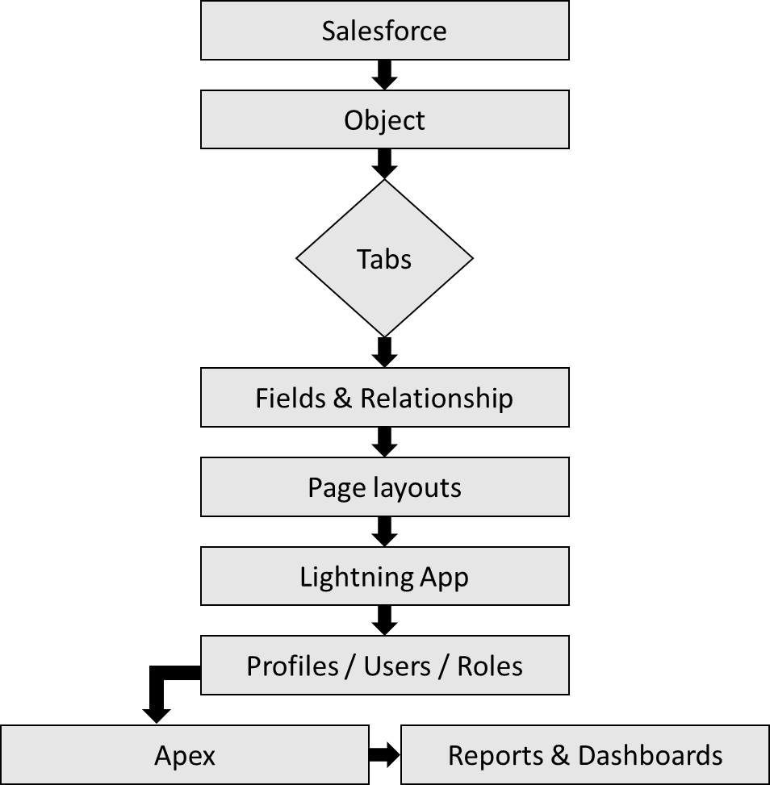

* + 1. Technical Architecture

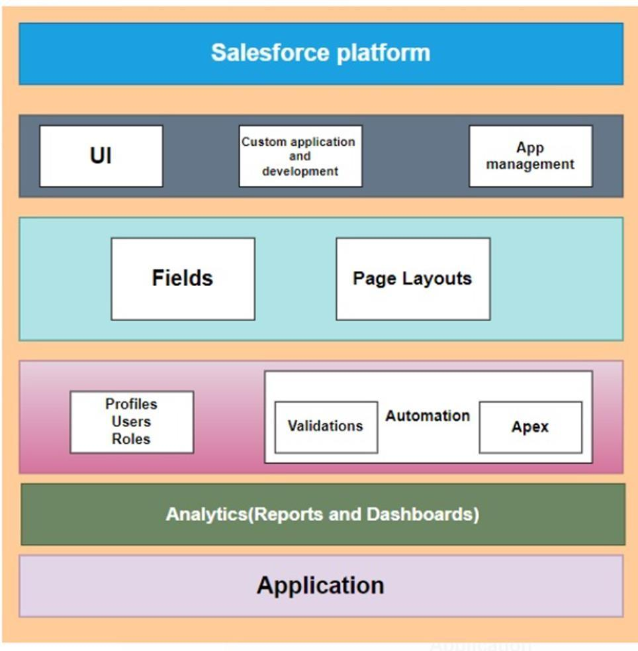

# CHAPTER-2 PREPARATION DATA MODELING

* 1. **Salesforce Developer Org**

In Salesforce, a Developer Sign Up or Developer Edition is a special type of Salesforce environment that is primarily used for development, testing, and learning purposes.

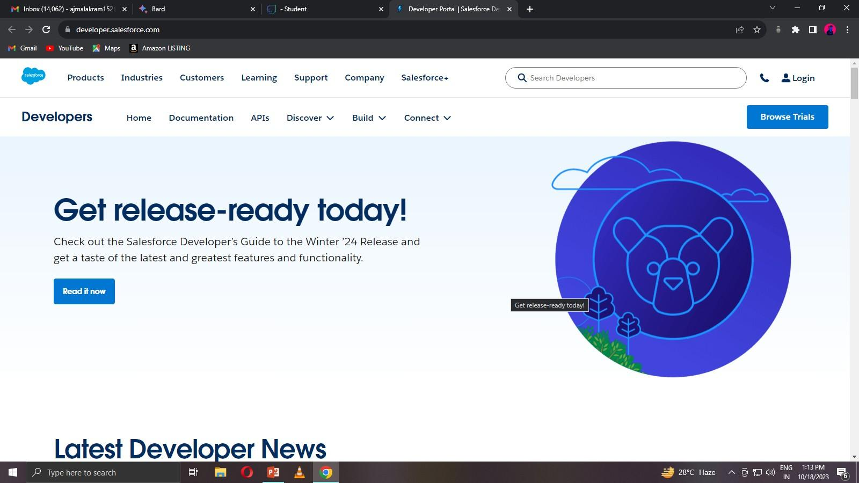

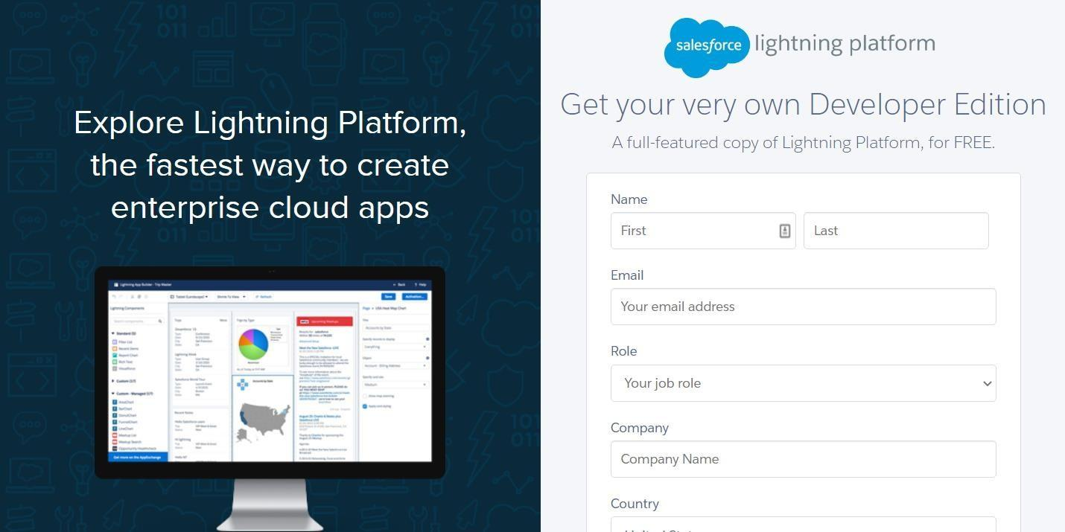

**Account Activation**

Activation tracks information about devices from which users have verified their identity.

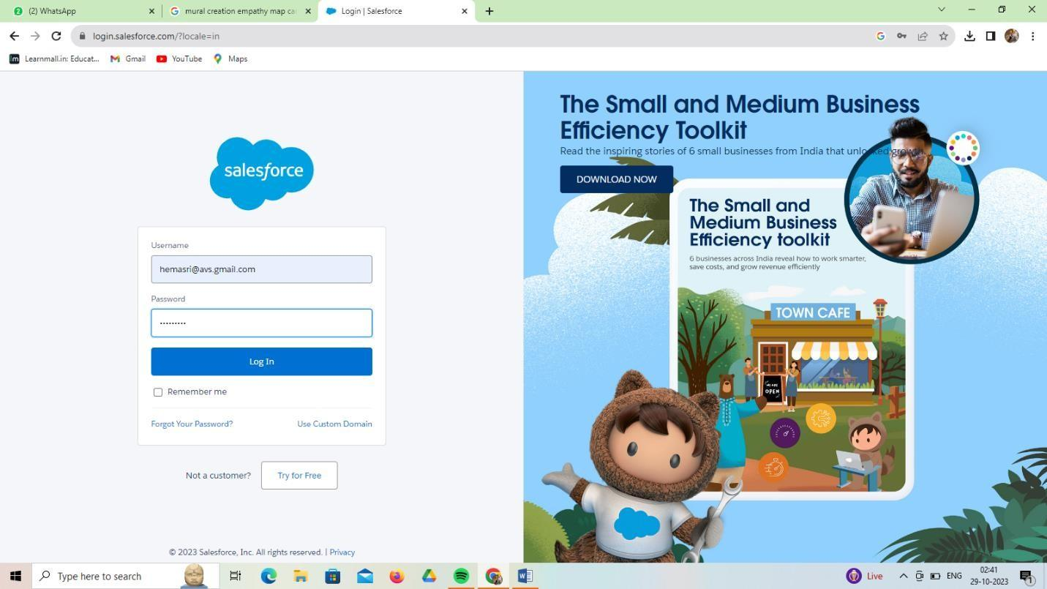

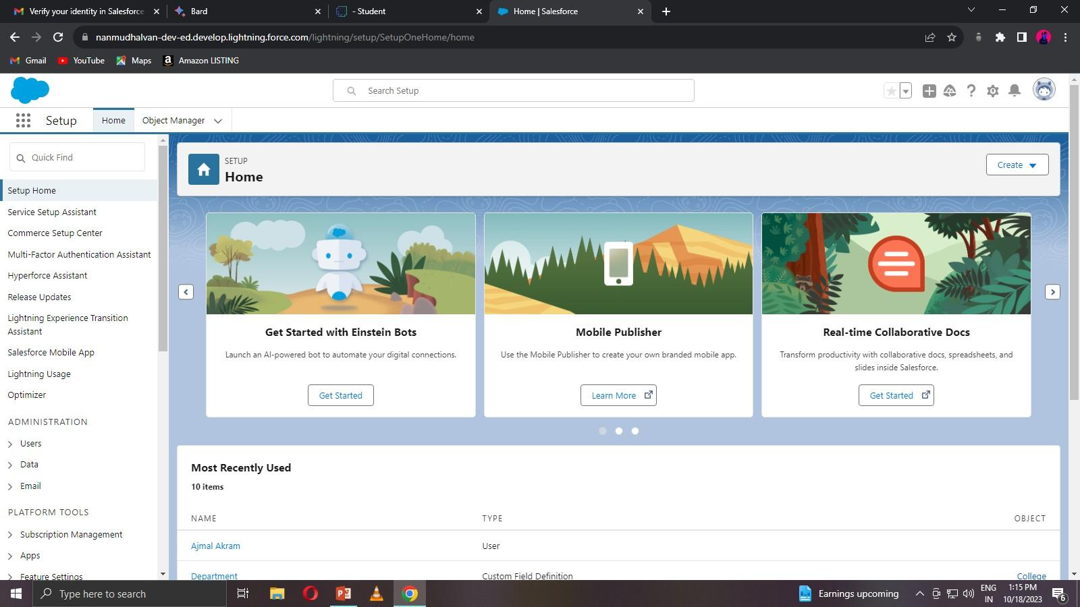

* 1. **Object Creation**

Salesforce objects are database tables that permit you to store data that is specific to an organization. Salesforce objects are of two types: Standard Objects: Standard objects are the kind of objects that are provided by salesforce.com such as users, contracts, reports, dashboards, etc. Custom objects: Students, Teachers, Parents, Others.

**Create the Consultants Object**

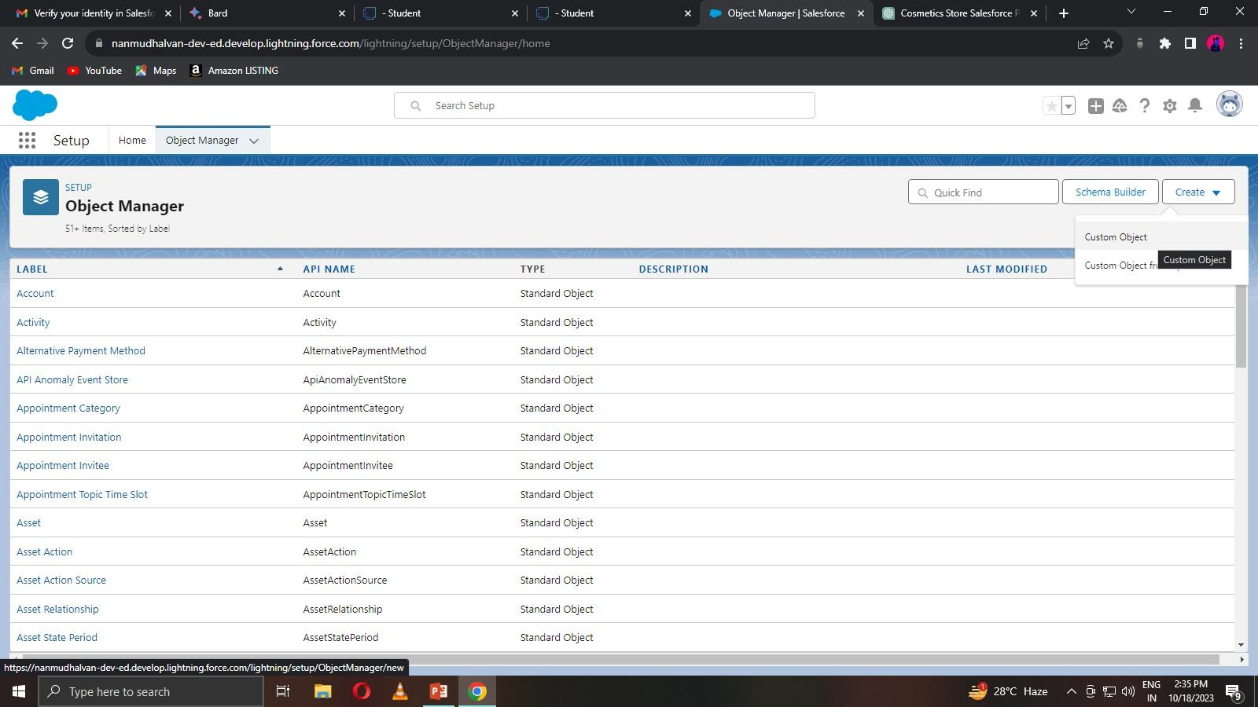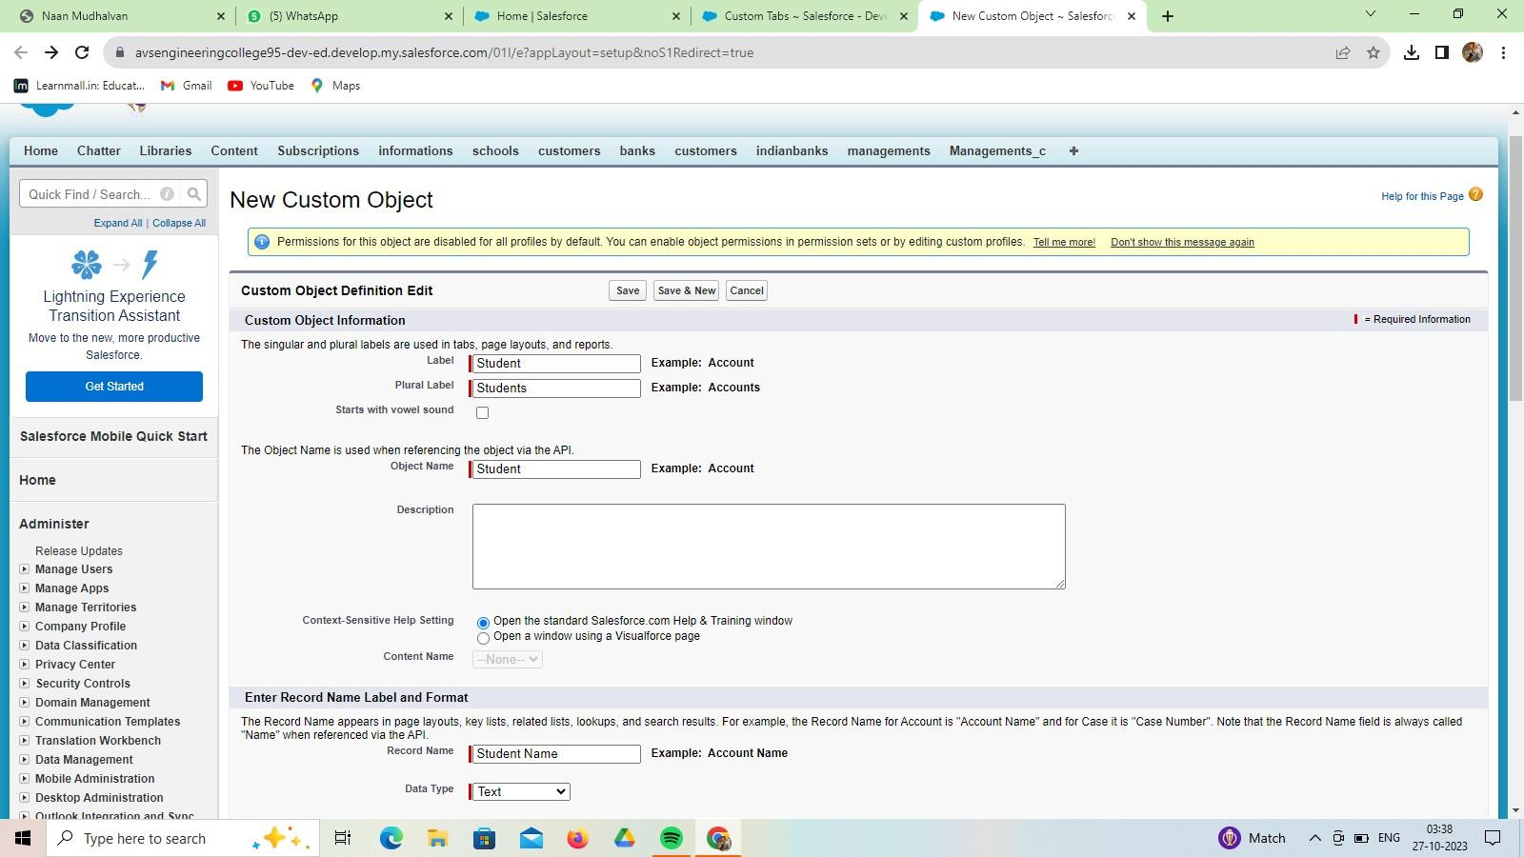

**Create the Retailers Object**

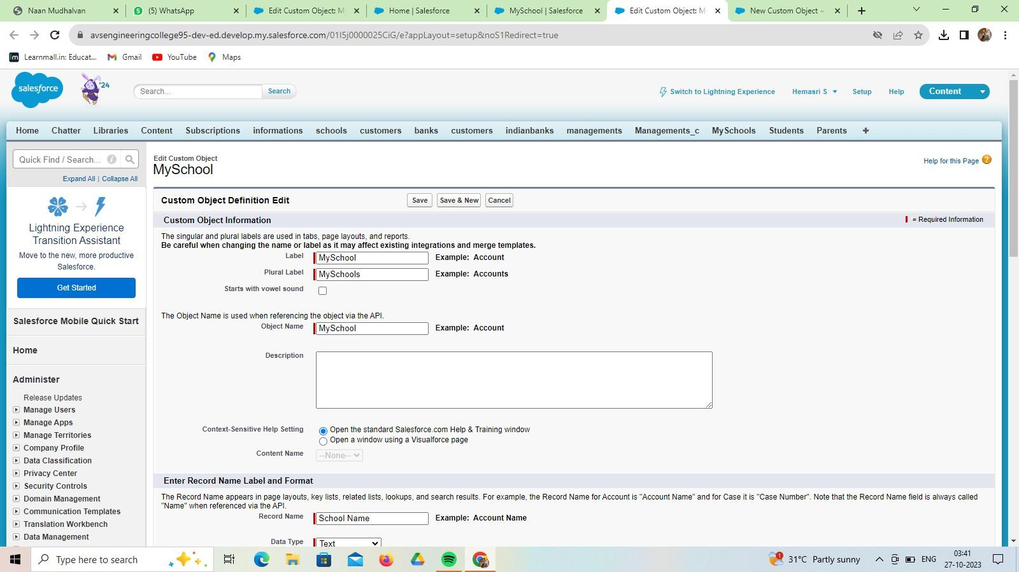

**Create the Others Object**

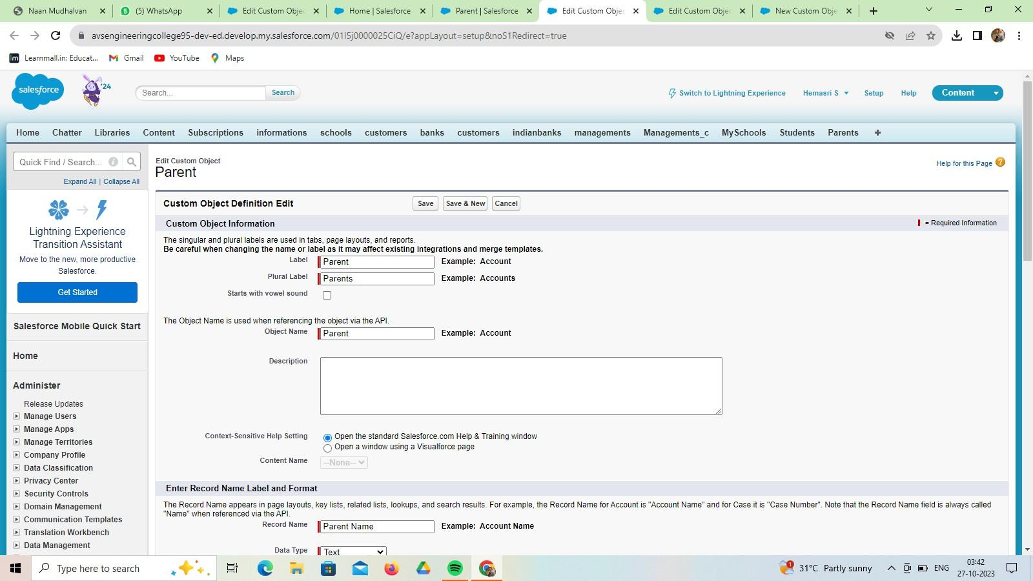

* 1. **Fields and Relationship**

An object relationship in Salesforce is a two-way association between two objects. Relationships are created by creating custom relationship fields on an object. This is done so that when users view records, they can also see and access related data.

**Fields in School Objects**

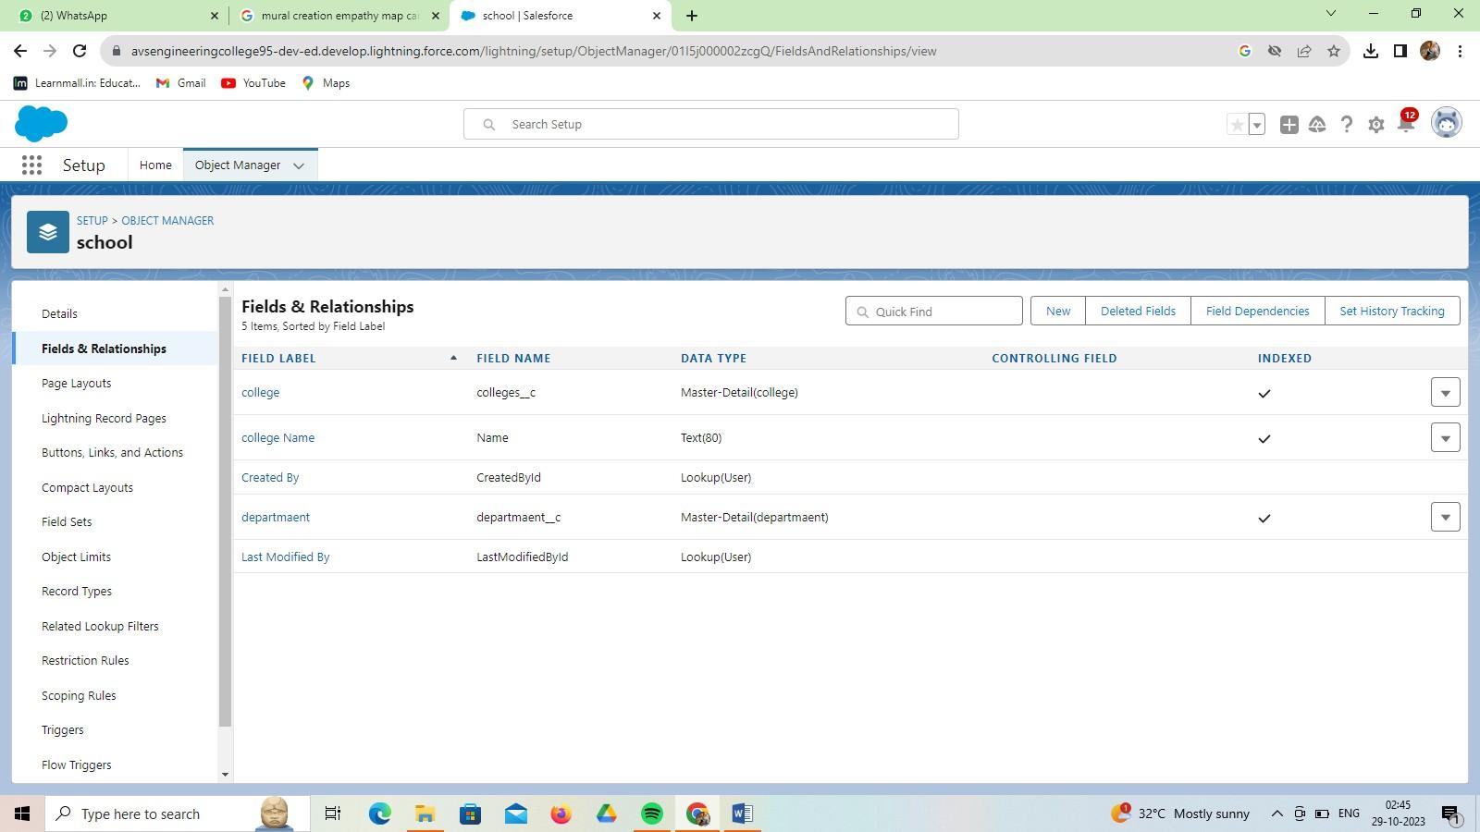

**Fields in Student Objects**

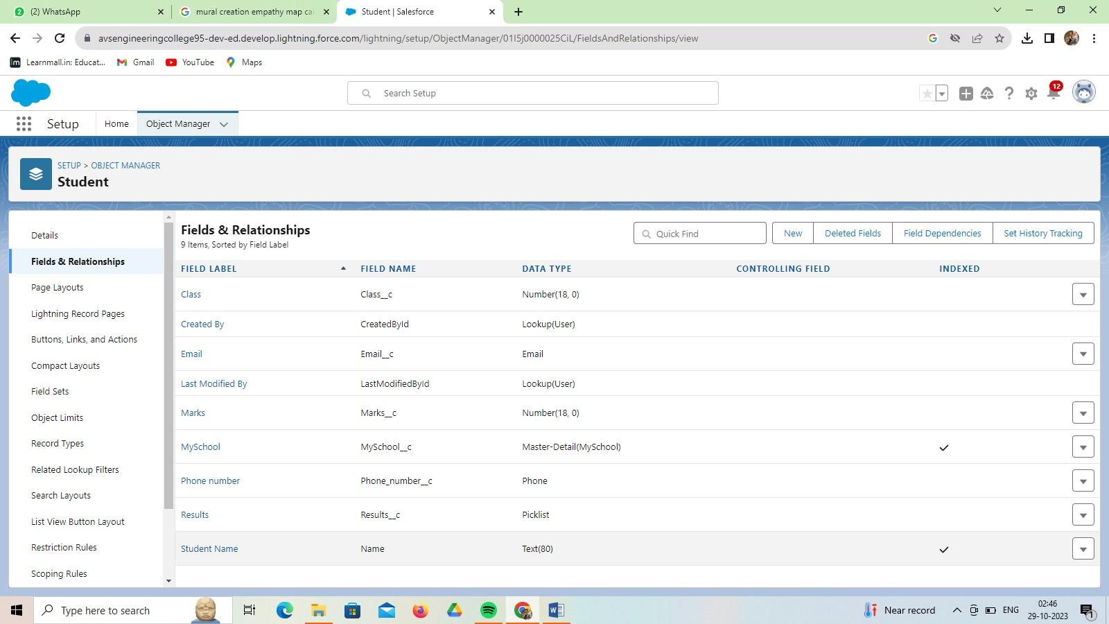

**Fields in Parent Objects**

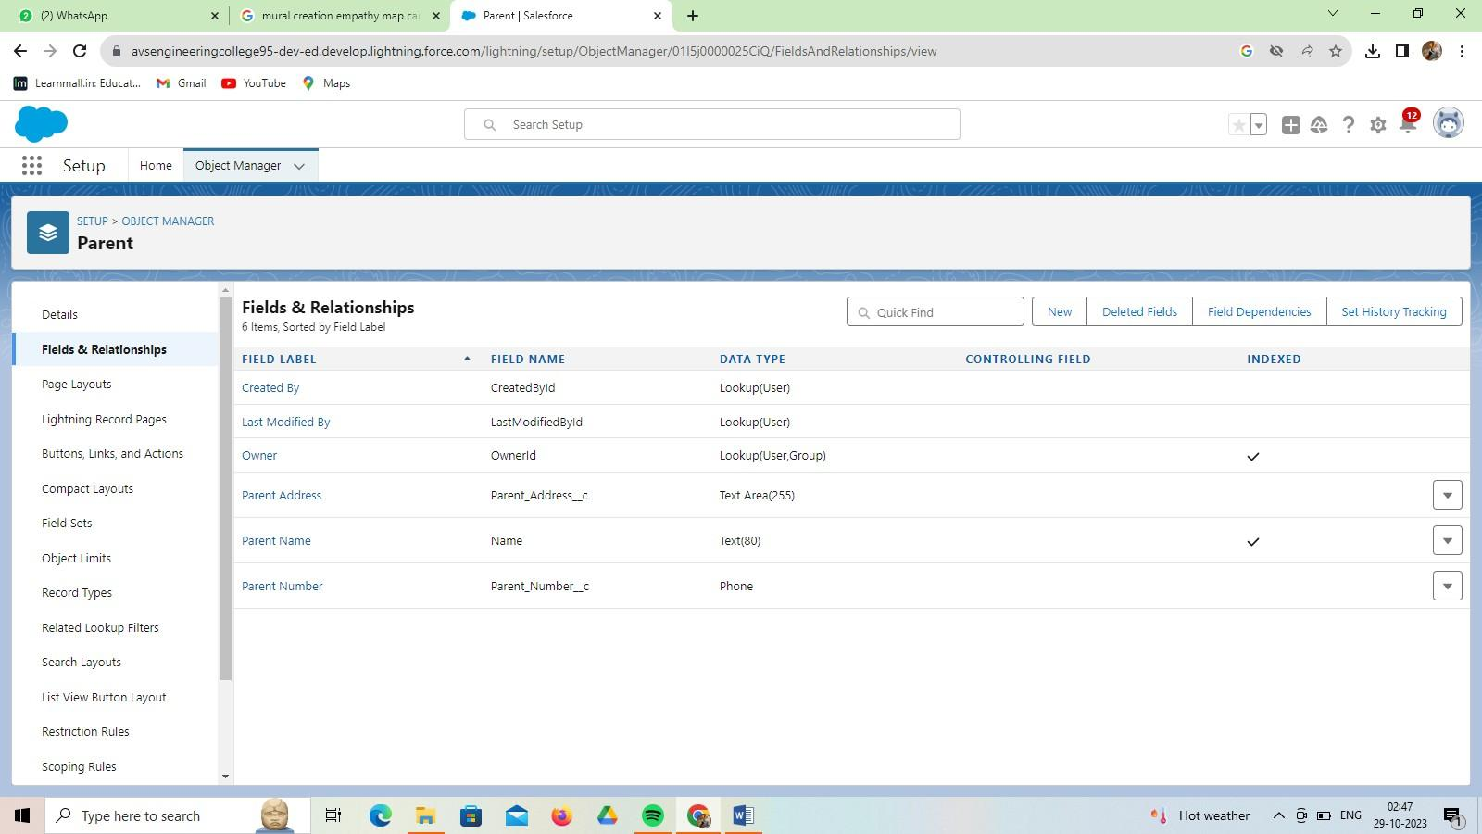

**Fields in Others Objects**

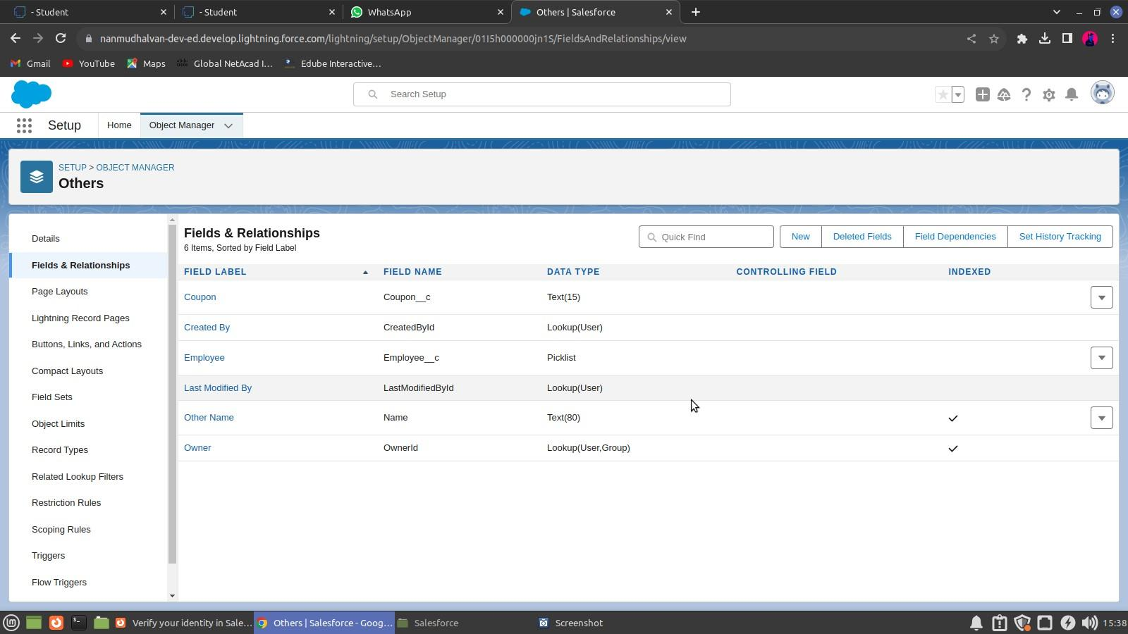

* 1. **Page Layouts**

In Salesforce, page layouts define the organization and arrangement of fields, buttons, related lists, and other components on an object's detail and edit pages. They allow you to control the user interface and tailor it to meet the specific needs of your organization.

**Select the School Layout page layout**

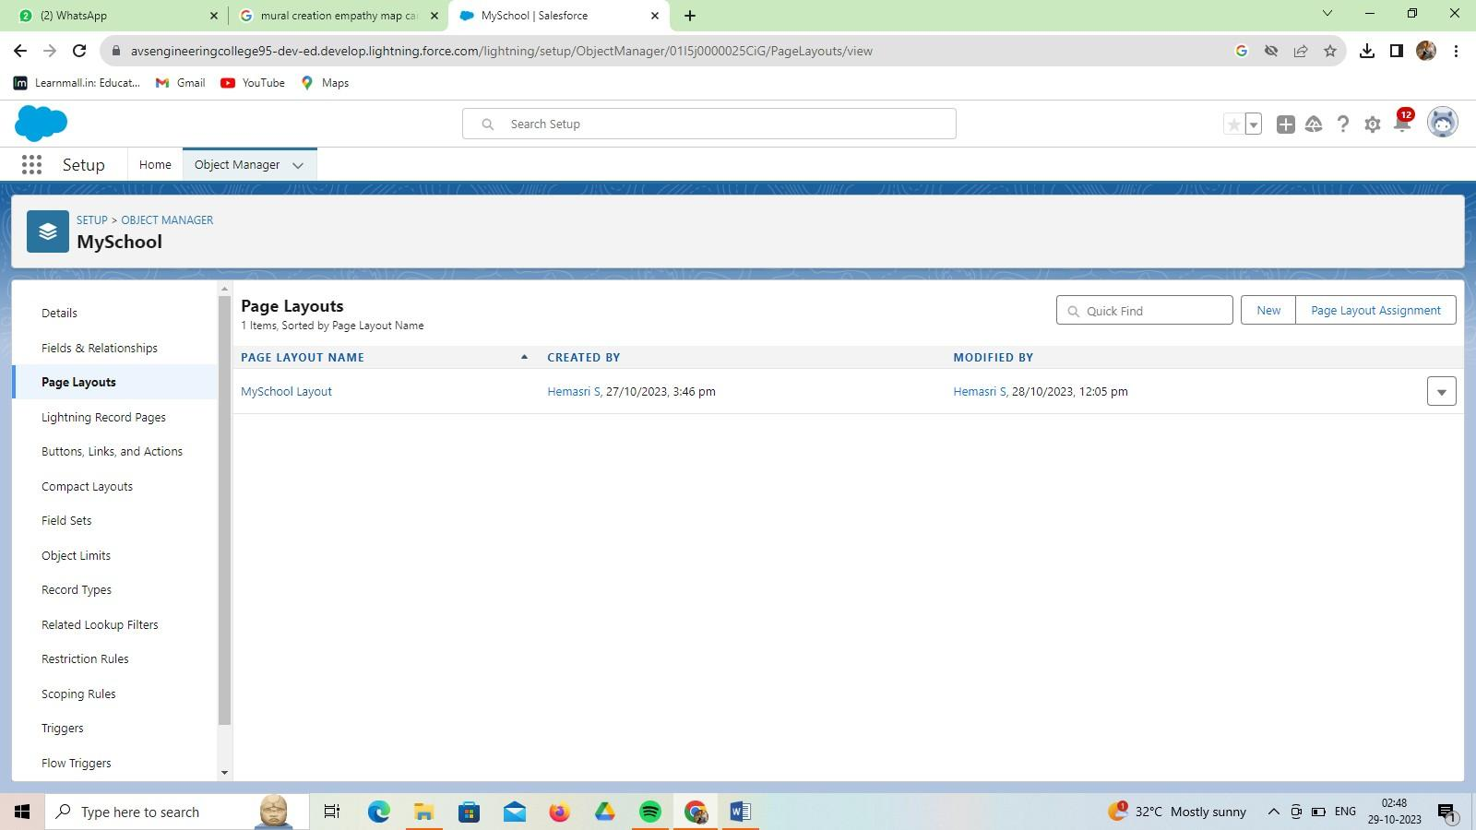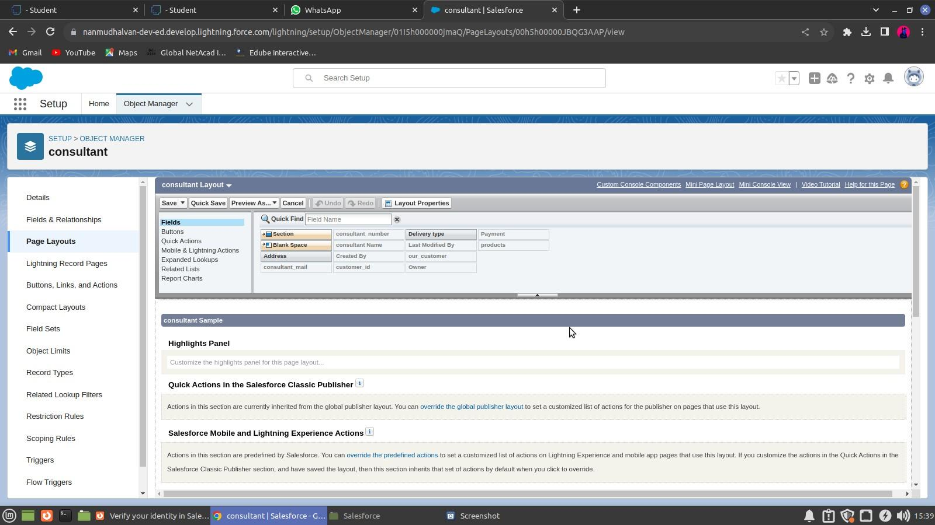

* 1. **The Lightning App**

An app is a collection of items that work together to serve a particular function. In Lightning Experience, Lightning apps give your users access to sets of objects, tabs, and other items all in one convenient bundle in the navigation bar. Lightning apps let you brand your apps with a custom Color and logo. You can even include a utility bar and Lightning page tabs in your Lightning app.

**To create a lightning app page**

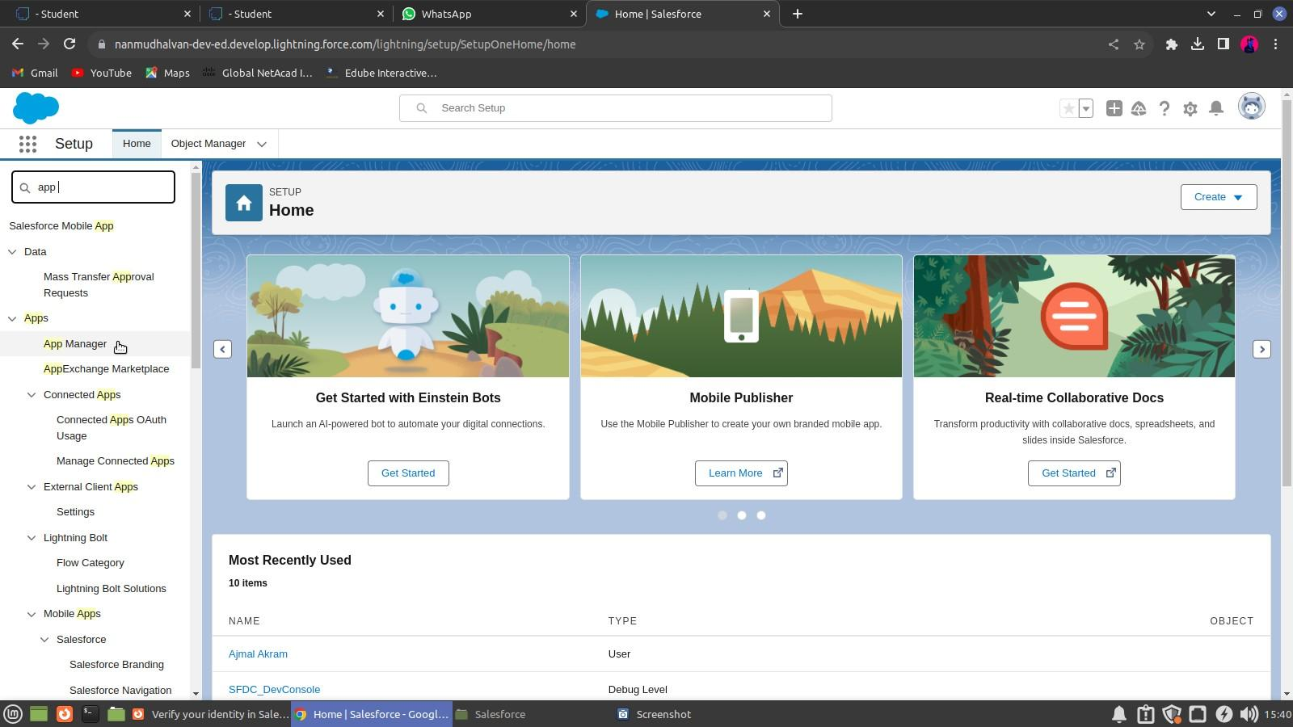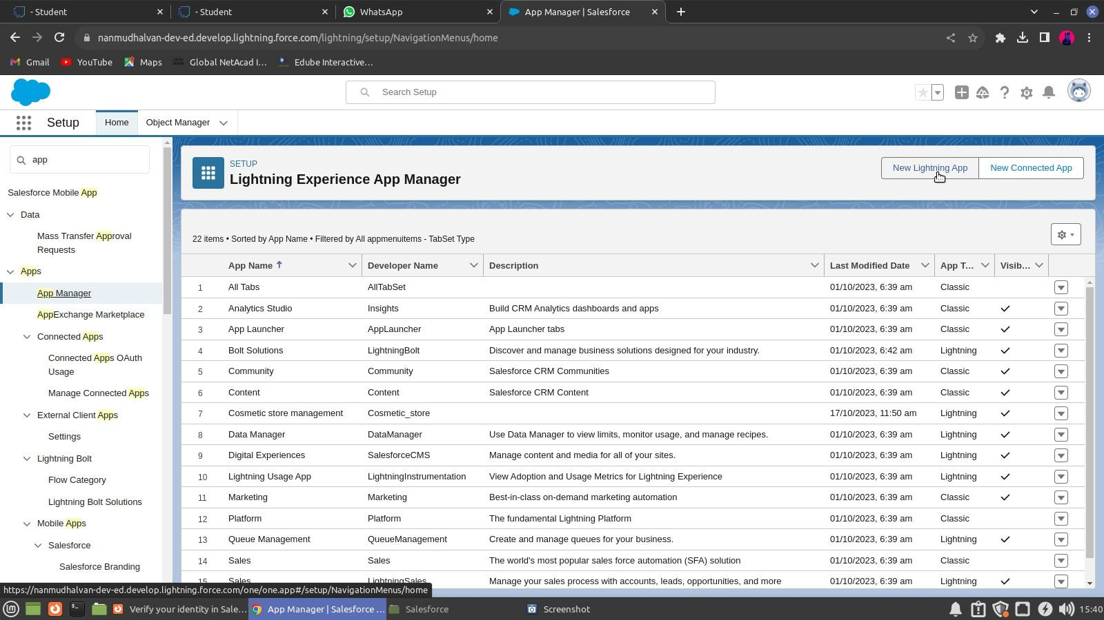

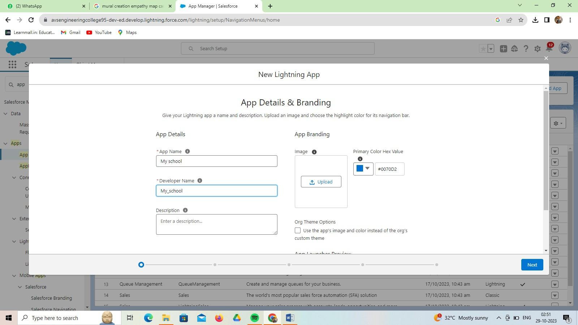

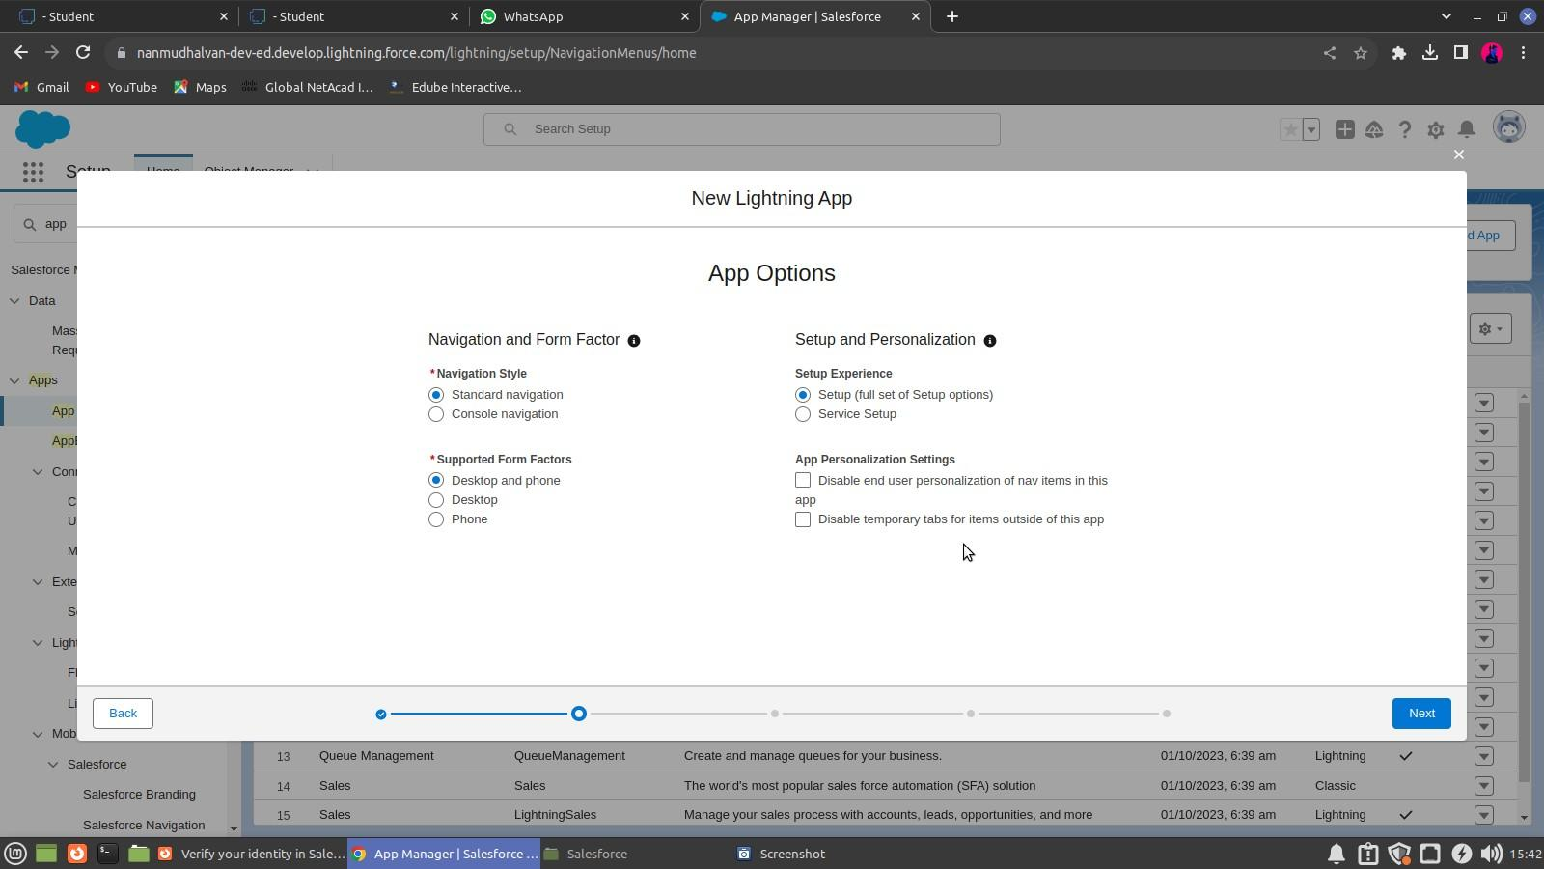

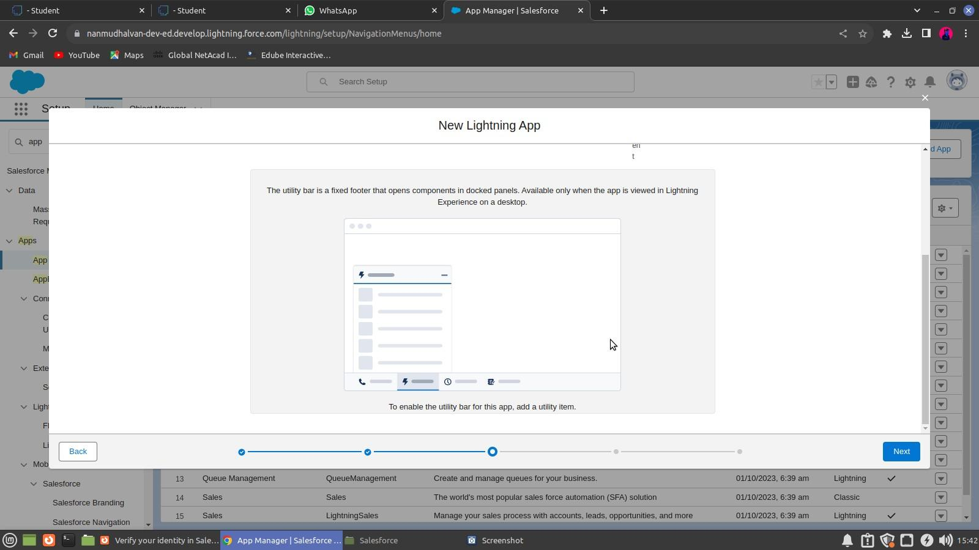

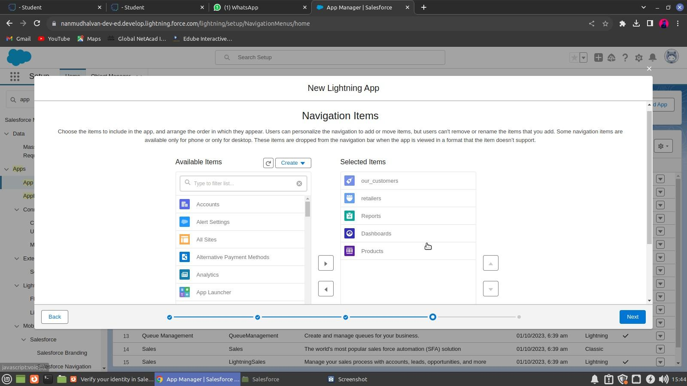

* 1. **Profile**

# CHAPTER-3

**USERS & DATA SECURITY**

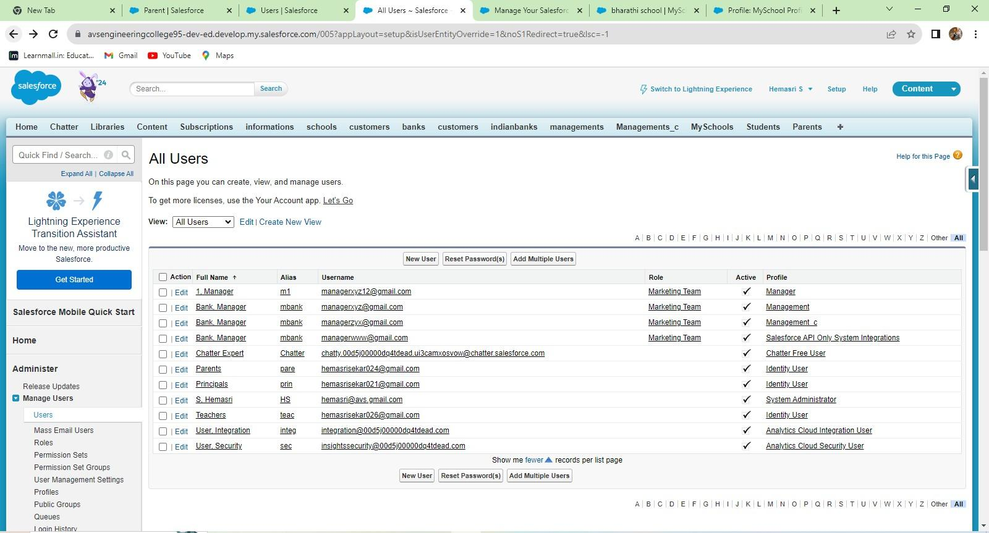

A profile is a group/collection of settings and permissions that define what a user can do in salesforce. A profile controls “Object permissions, Field permissions, User permissions, Tab settings, App settings, Apex class access, Visualforce page access, Page layouts, Record Types, Login hours & Login IP ranges.

**Creating a Profiles**

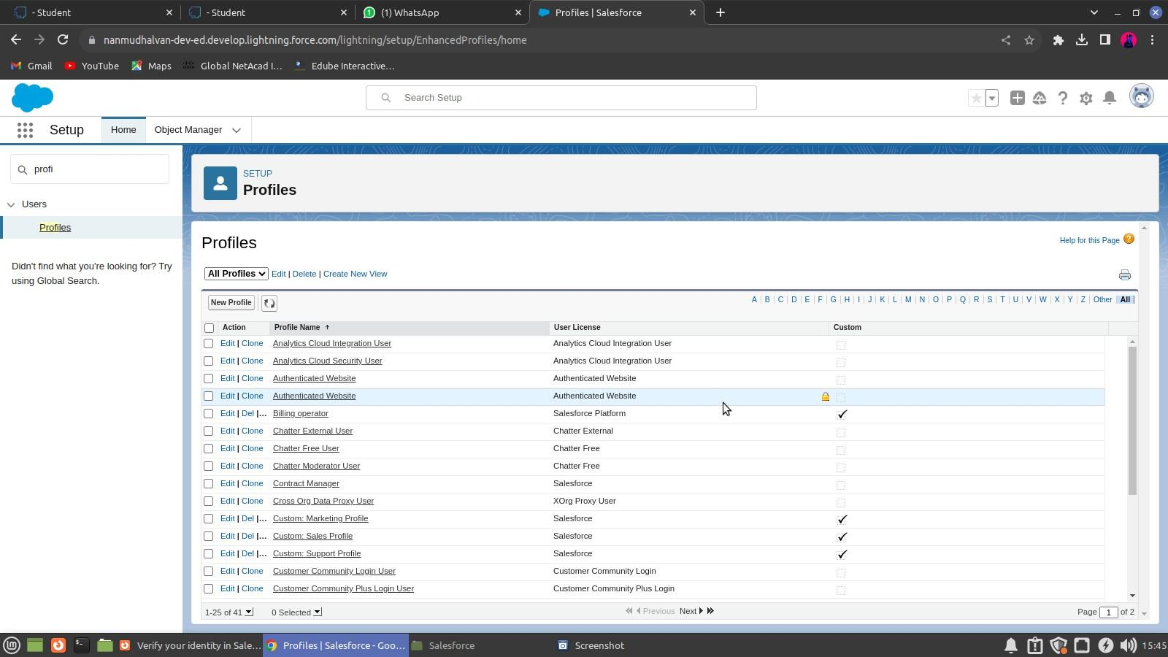

**To create a new profile (Store Supervisor)**

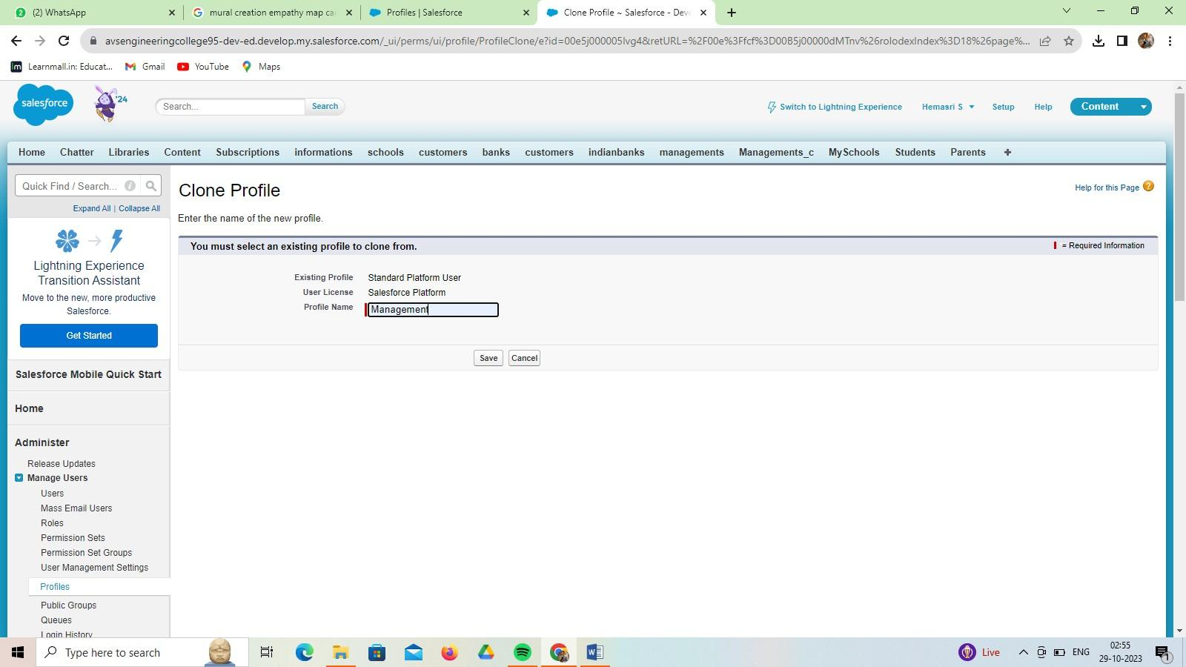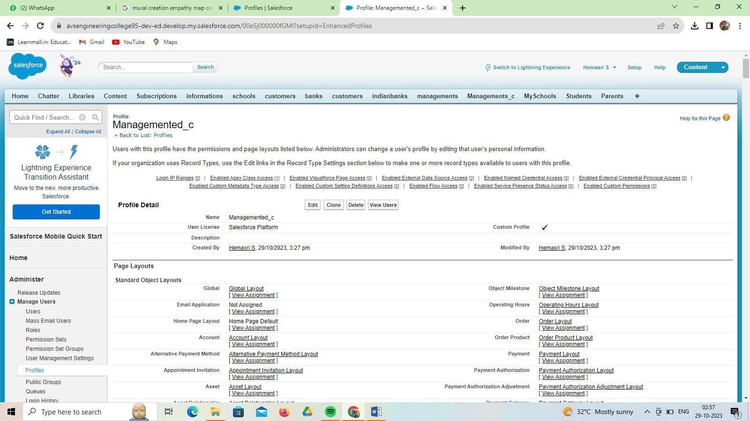

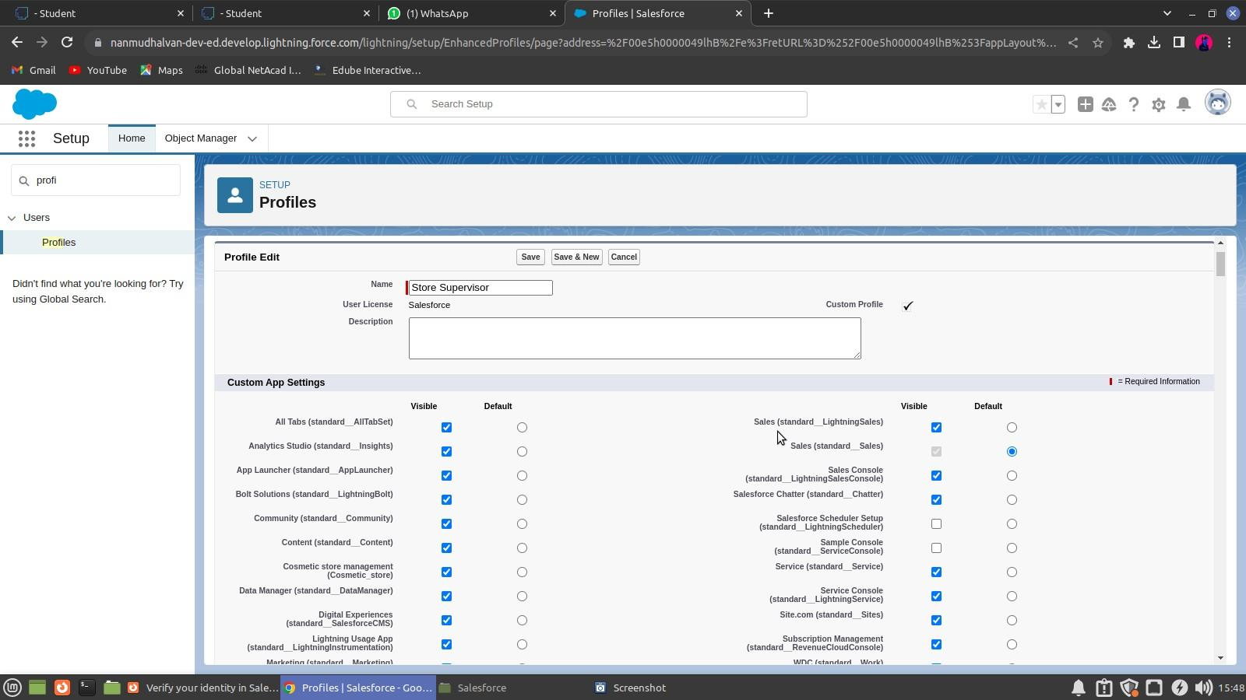

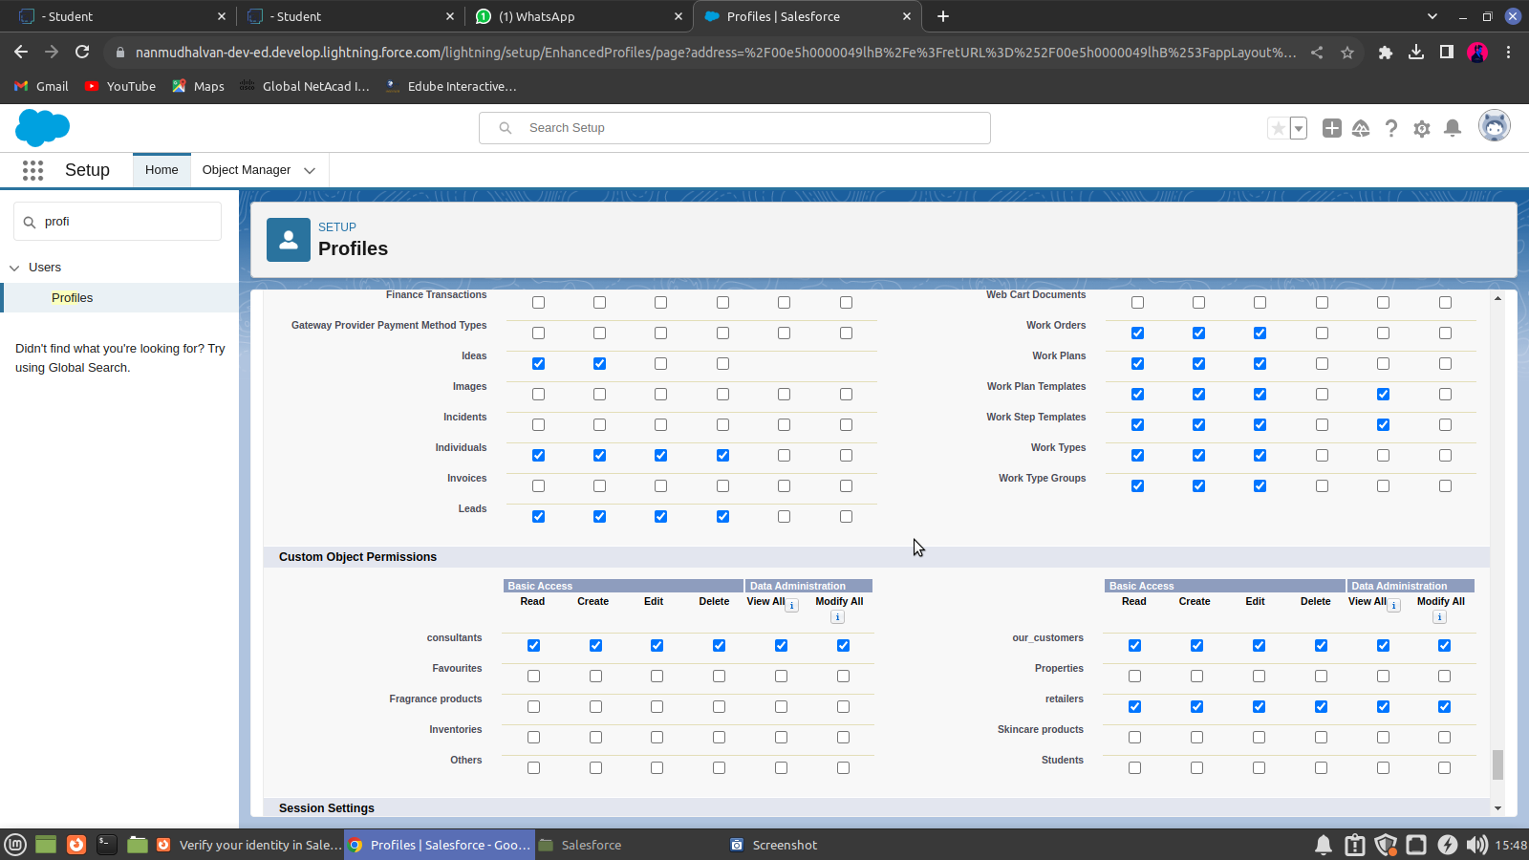

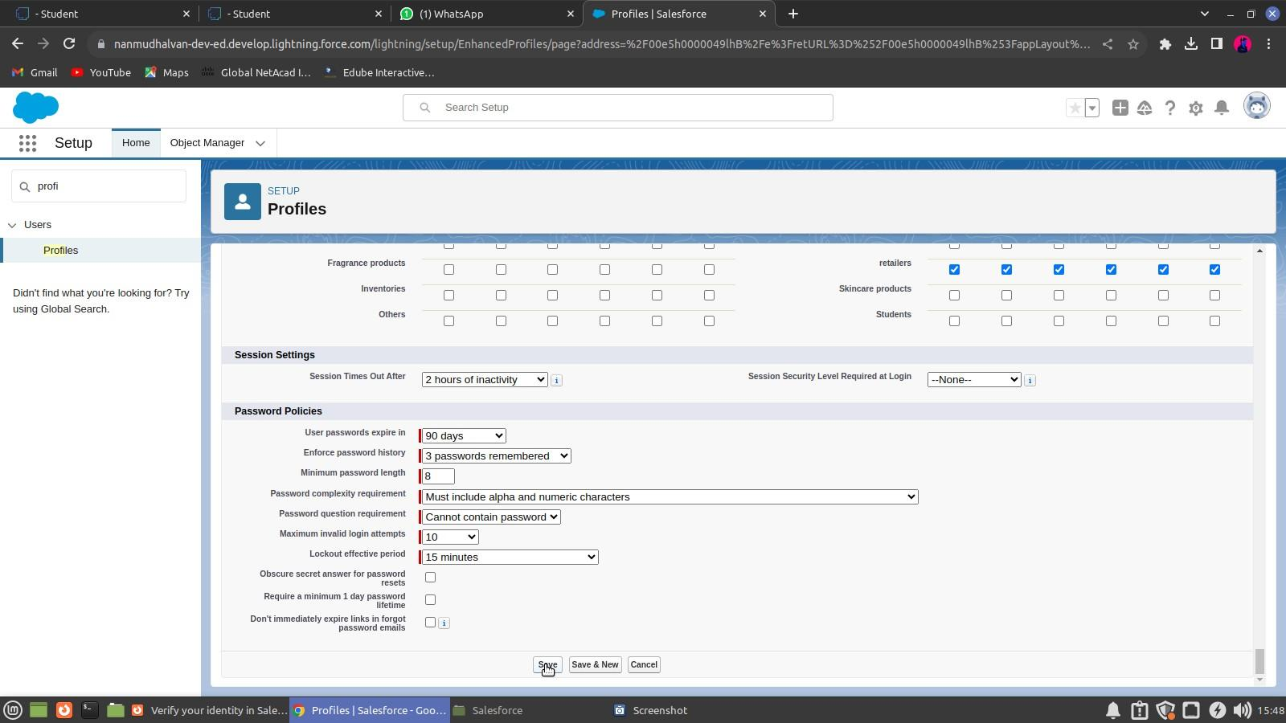

**To create a new profile (management Operator)**

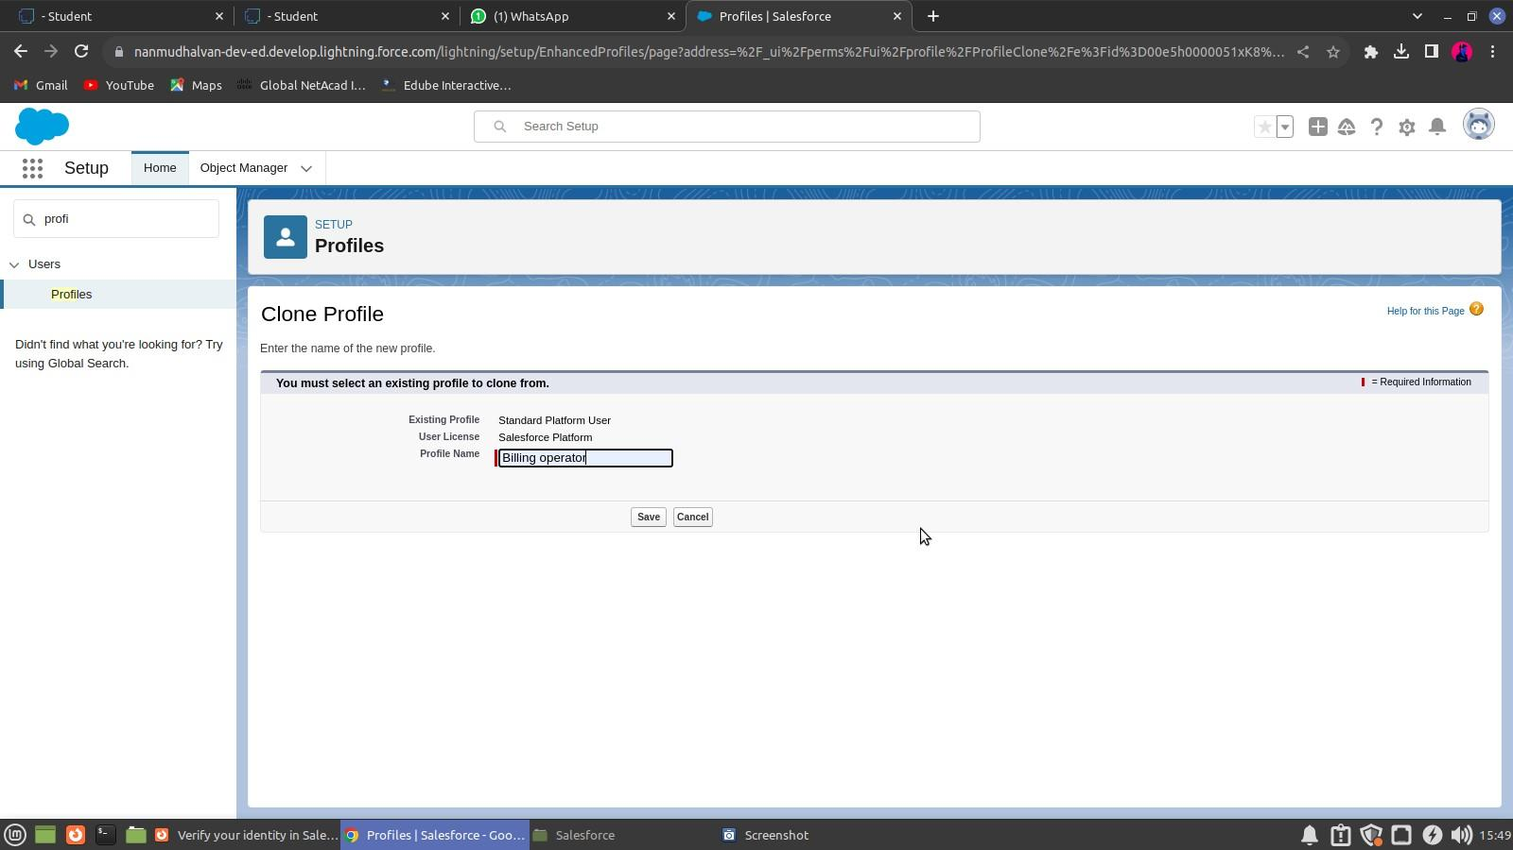

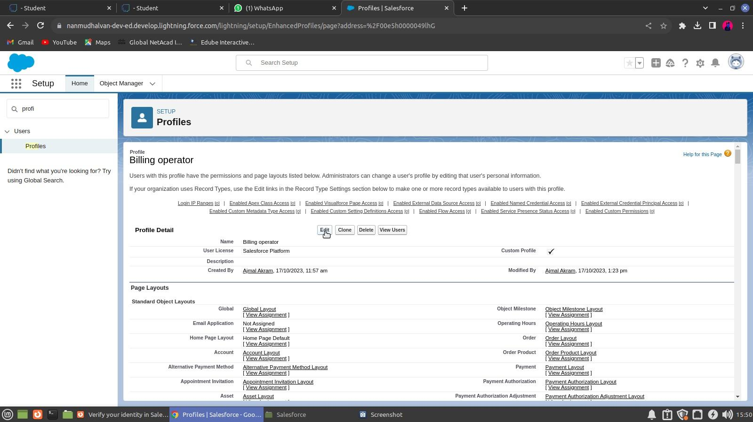

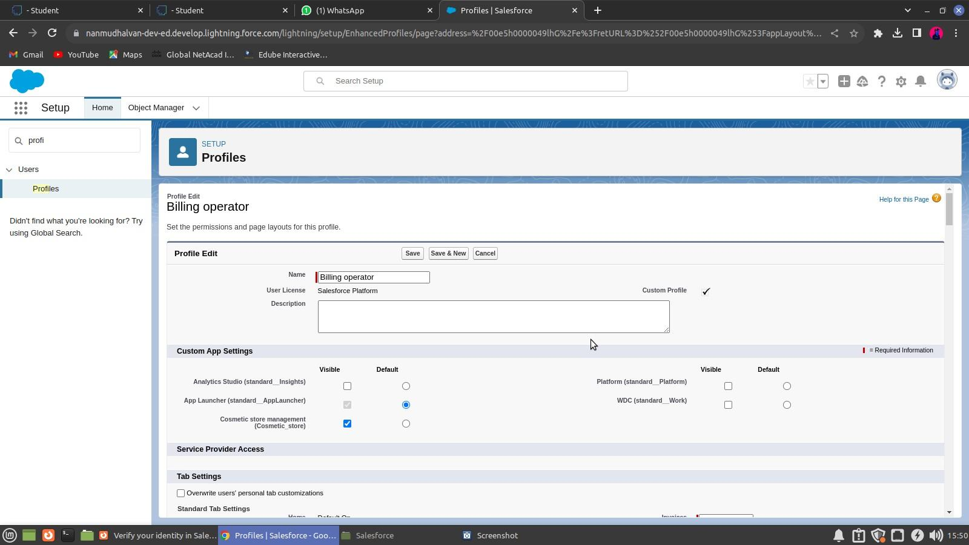

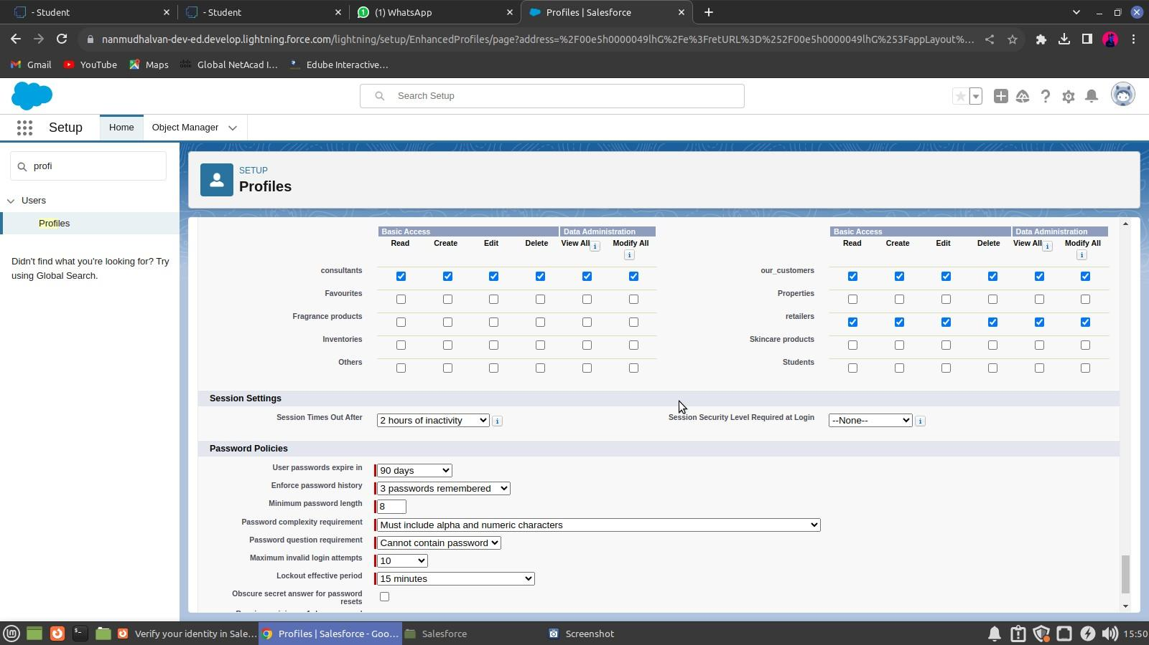

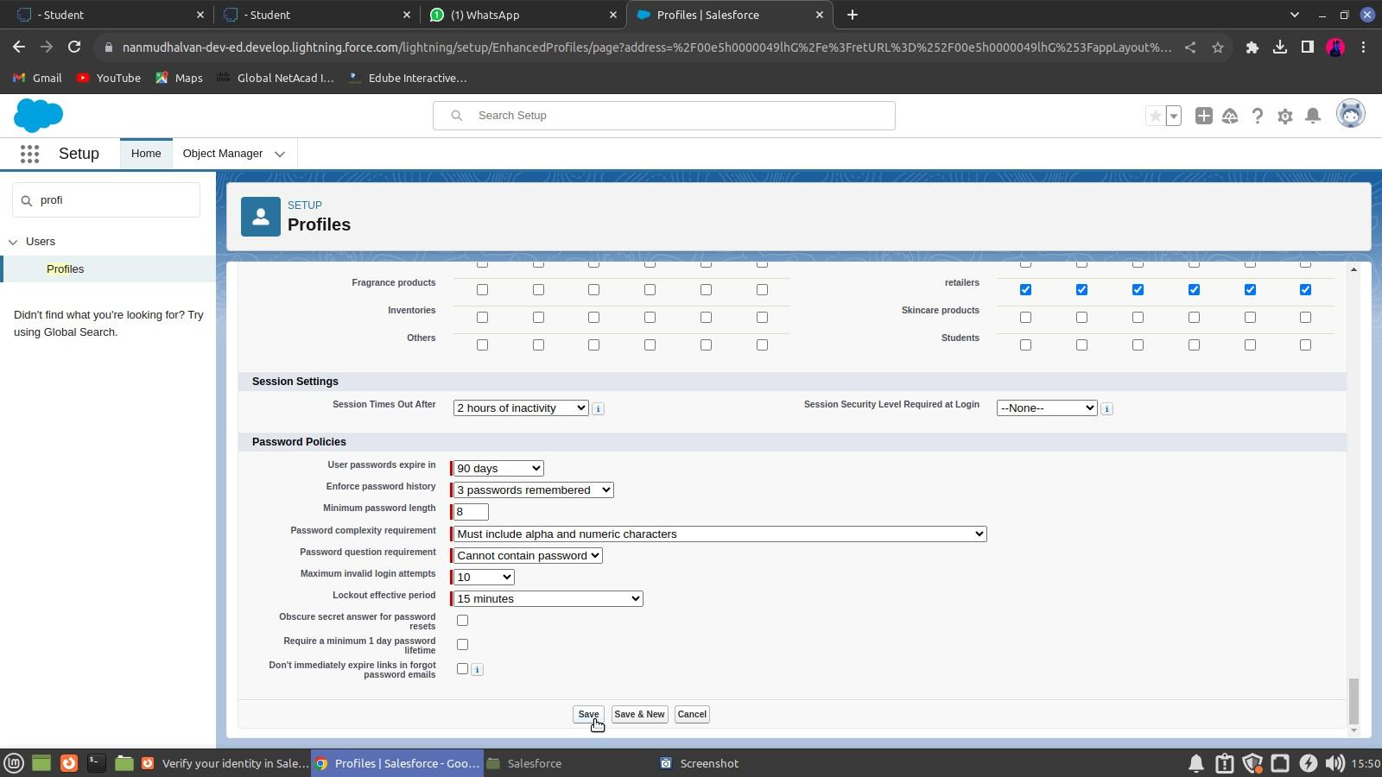

* 1. **Setup Roles**

Salesforce roles are record-level access controls that define what data a user can see in Salesforce.

**Creating a Role**

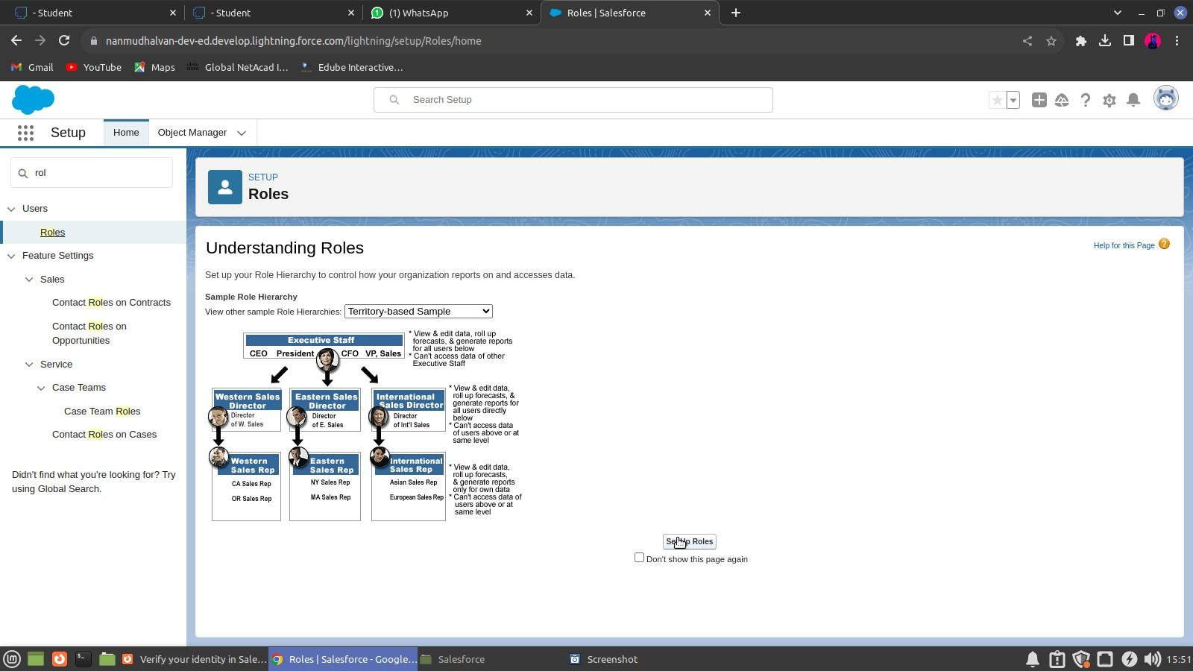

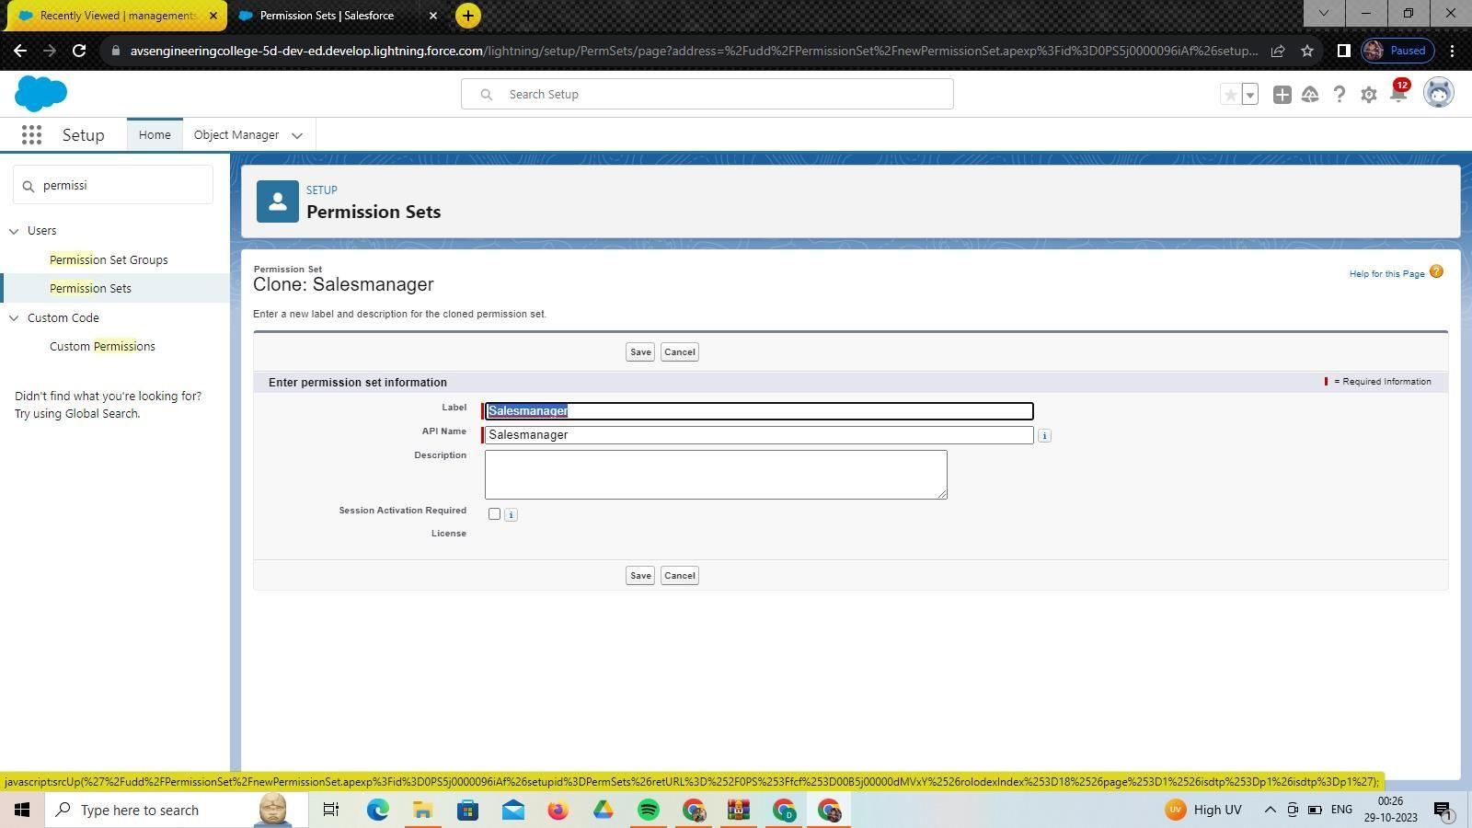

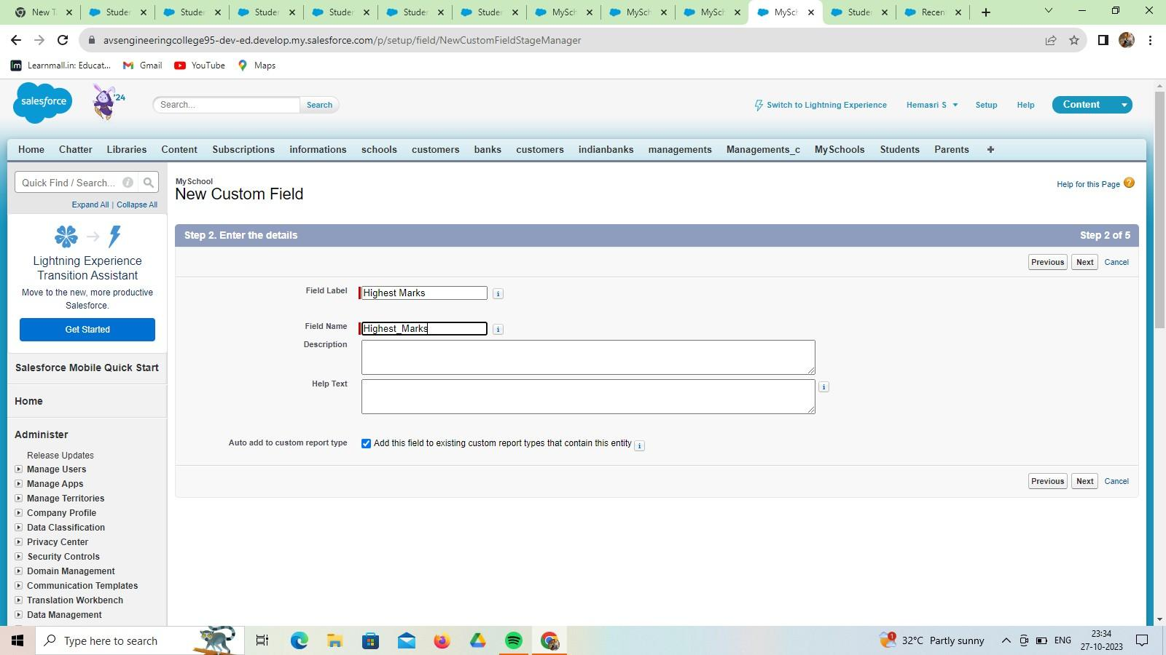

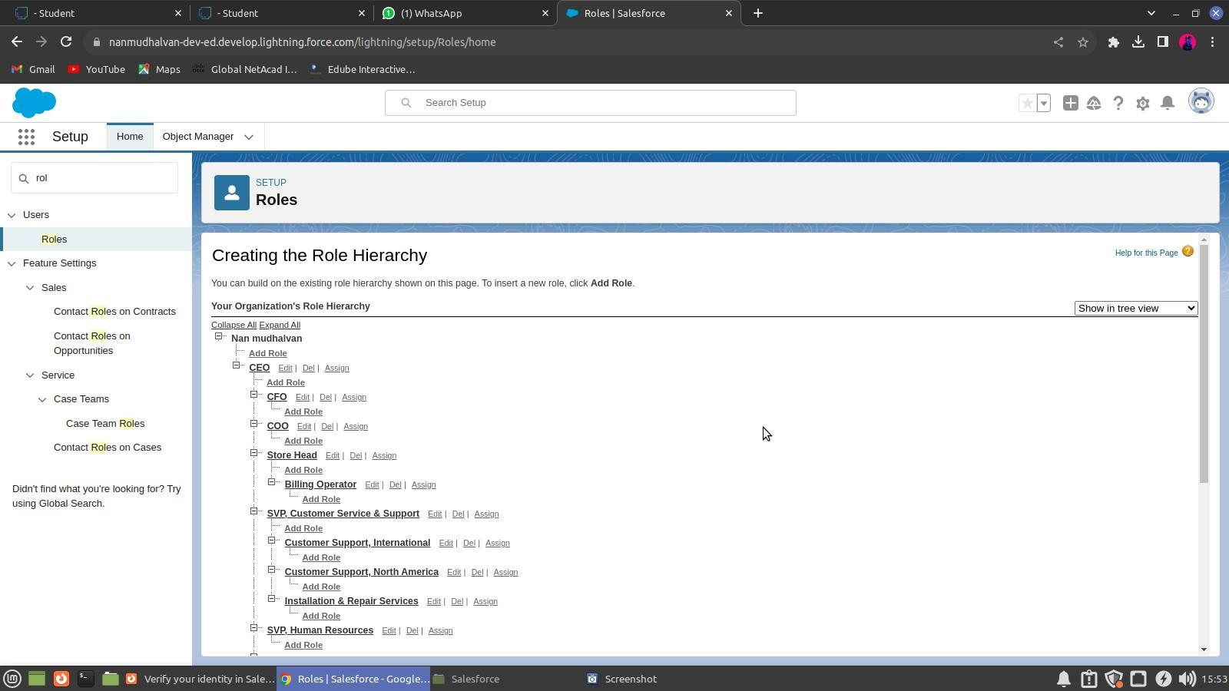

* 1. **Users**

A user is anyone who logs in to Salesforce. Users are employees at your school, such as sales reps, managers, and IT specialists, who need access to the company's records. Every user in Salesforce has a user account.

**Creating A Users**

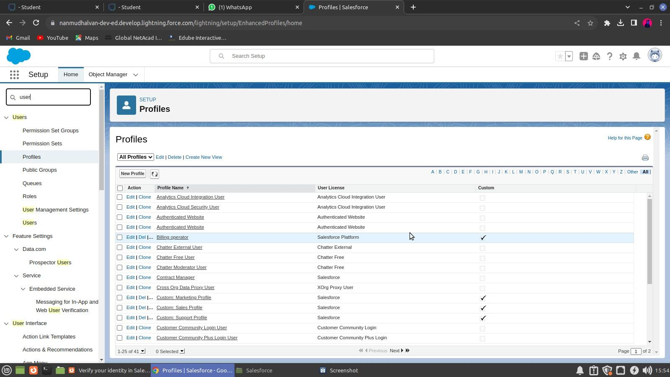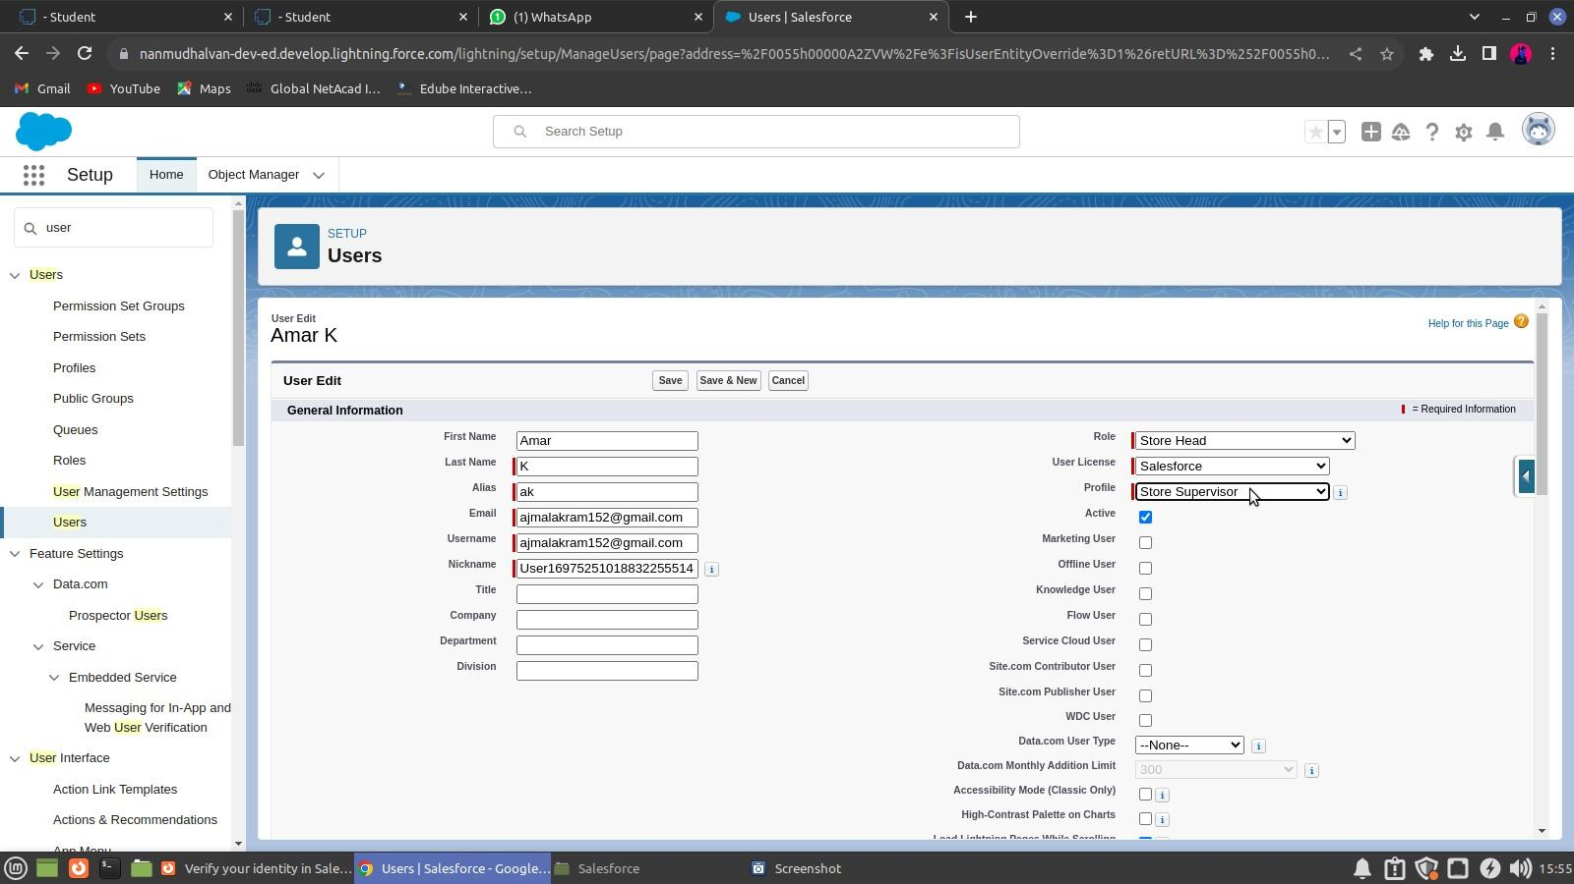

**Creating another Users**

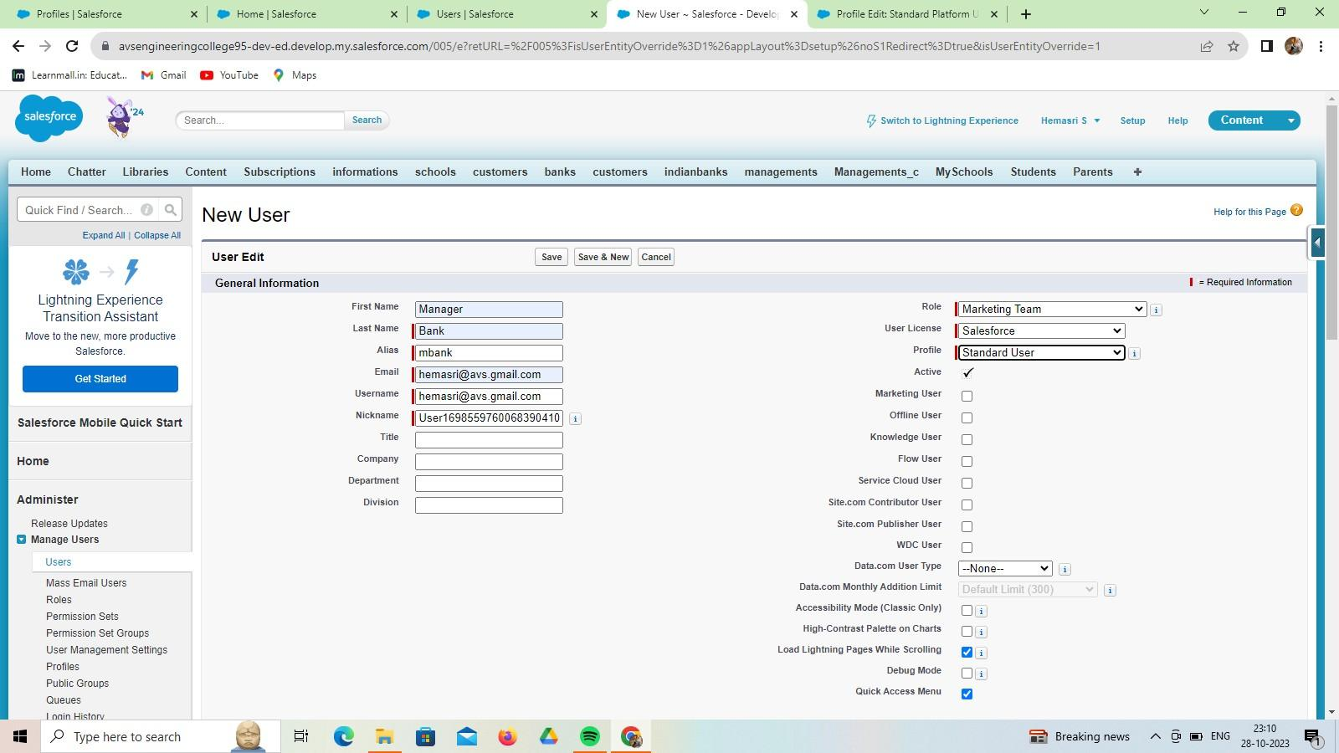

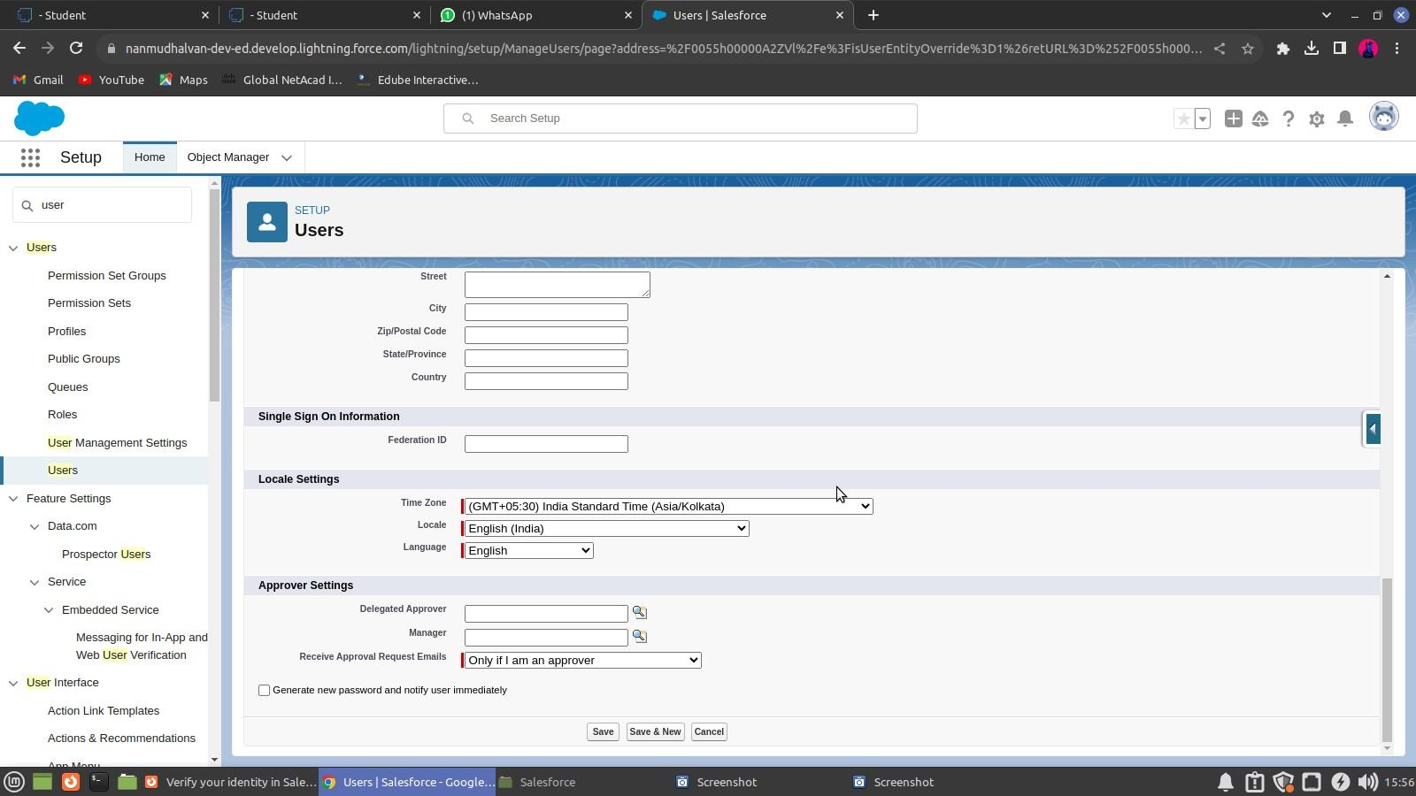

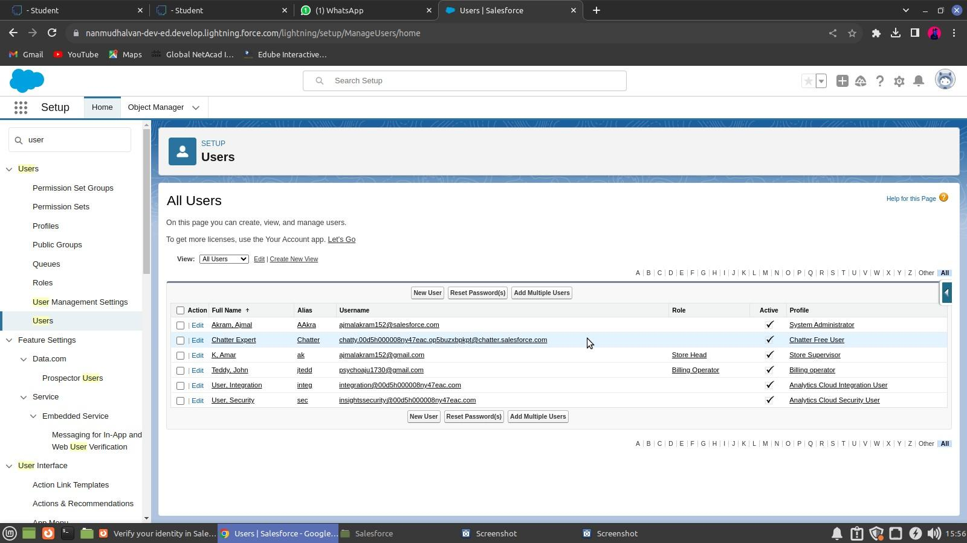

* 1. **User Adoption & Approval**

It is the interaction with database and their records.

**Create Our Customer Record**

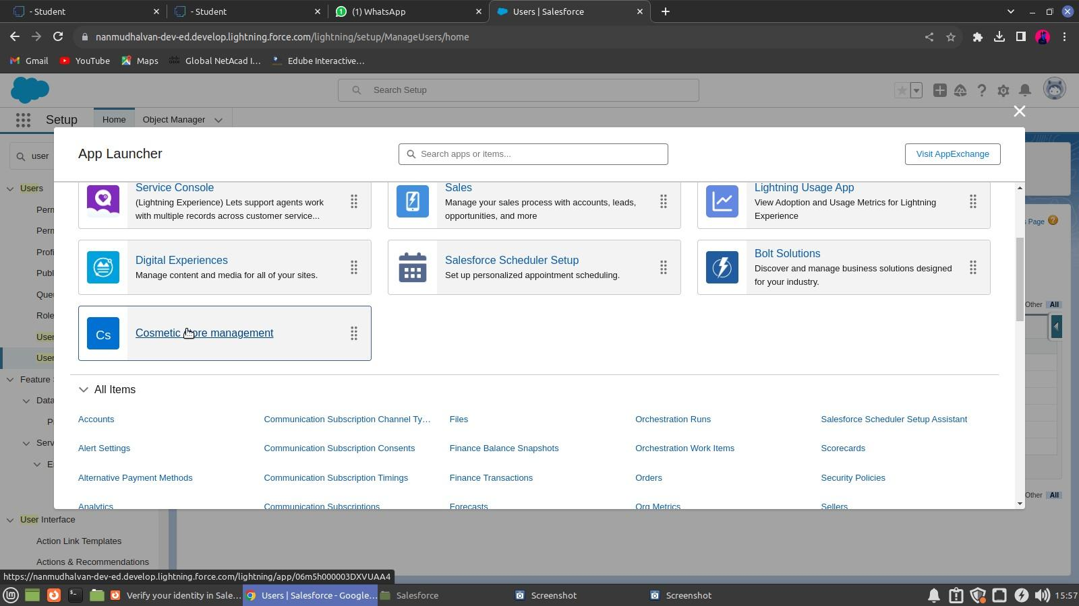

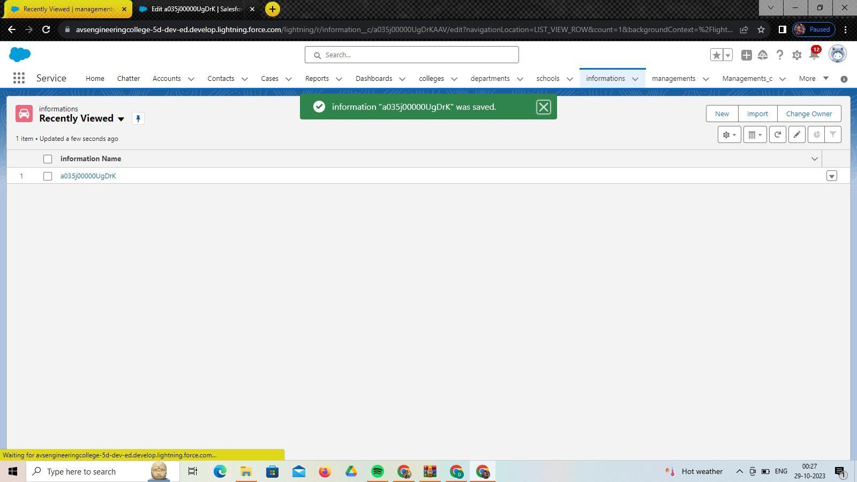

**View Record (Our school)**

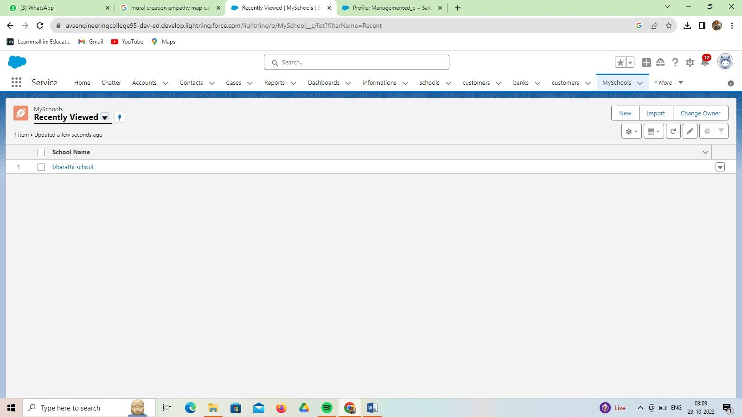

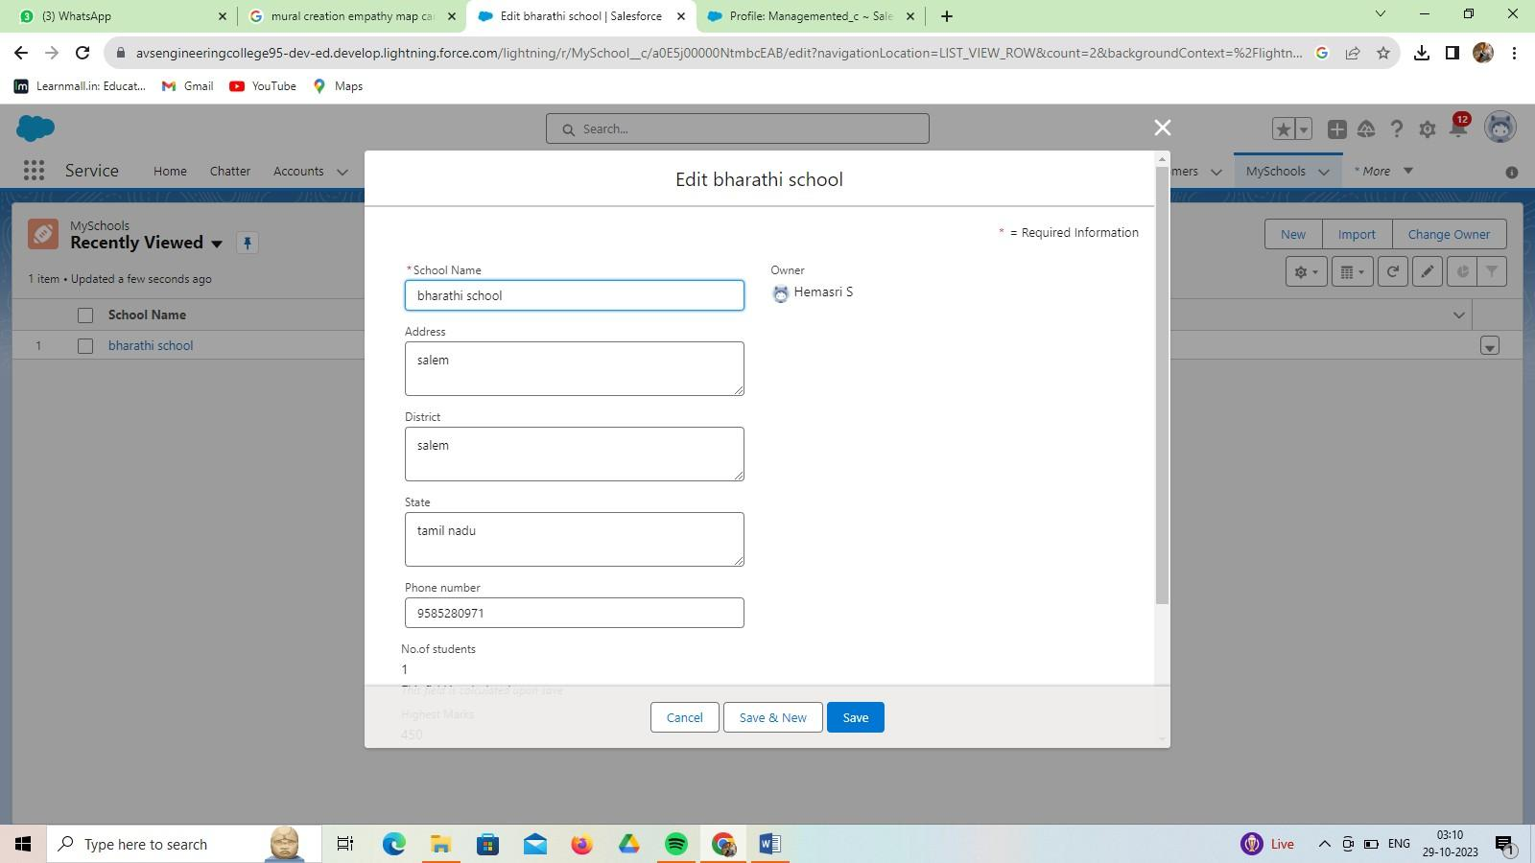

**Delete Record (Our school)**

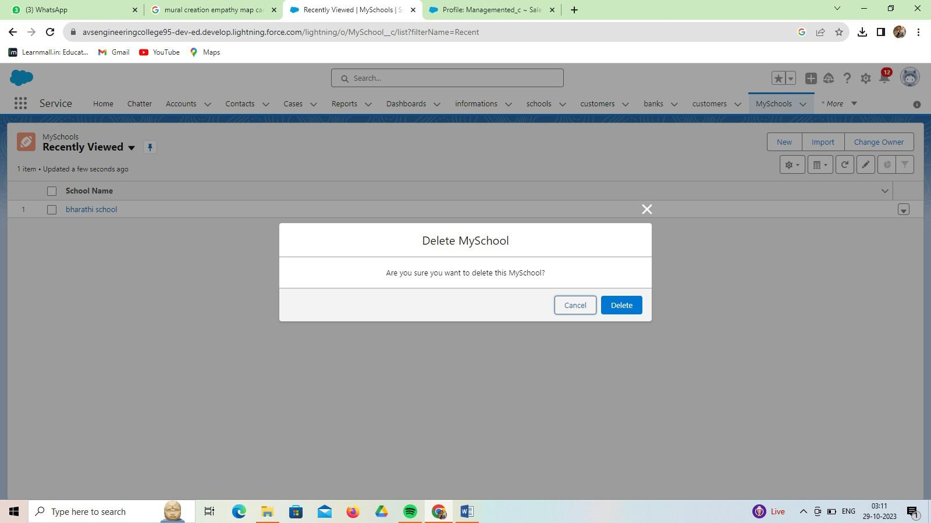

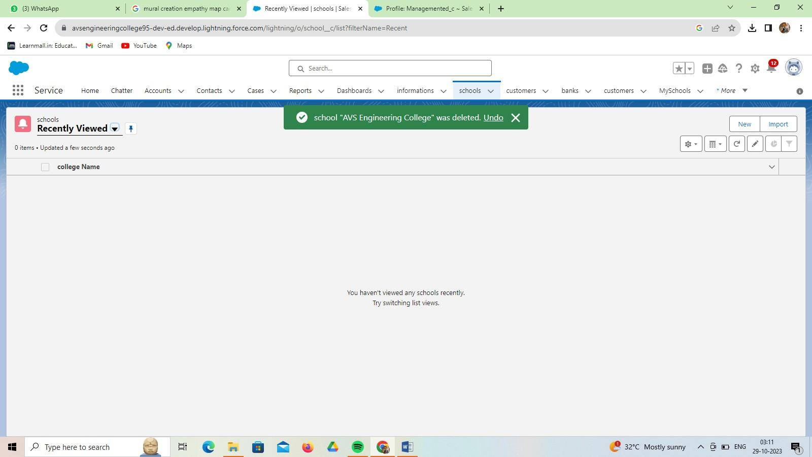

**Data Import**

The Data Import Wizard is one of various tools available to Salesforce users for importing data. The tool is best used when importing data into the Account, Contact, Lead, or Solution objects along with any custom objects within your Salesforce organization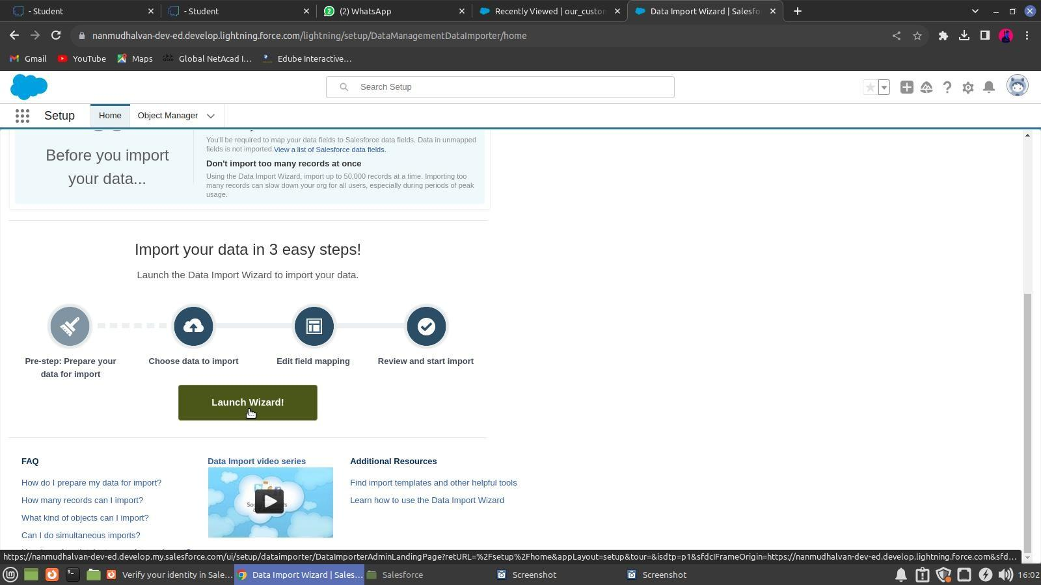

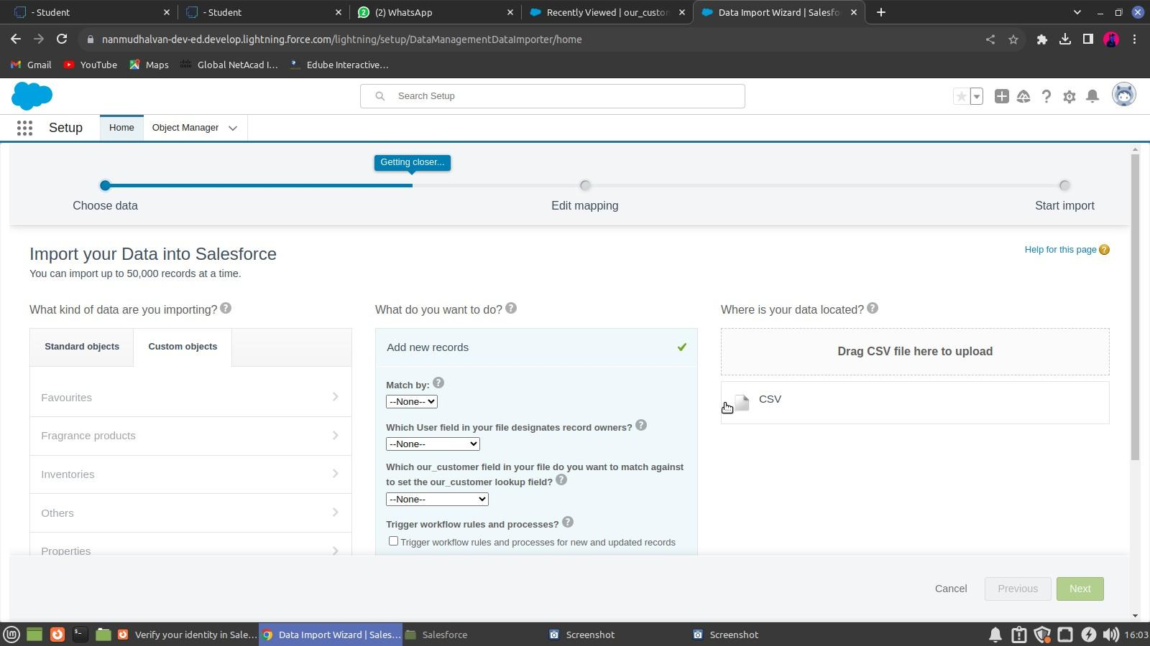

Programming for school records:

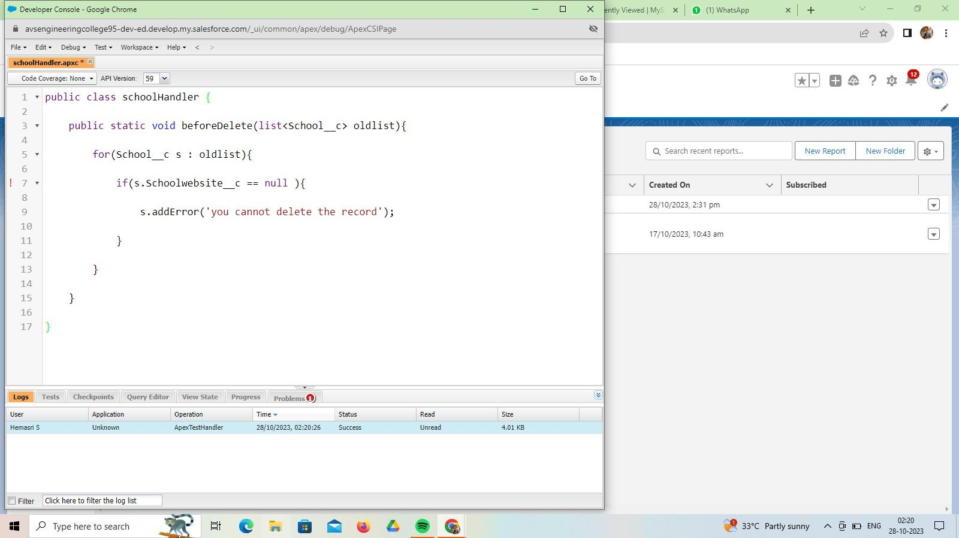

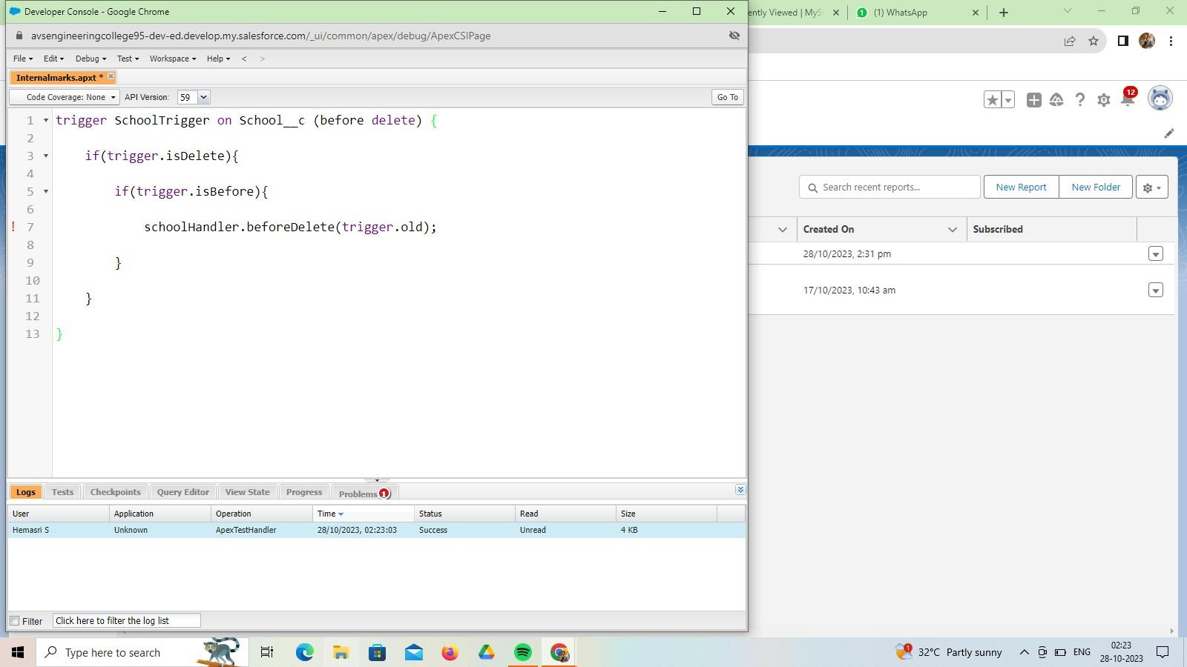

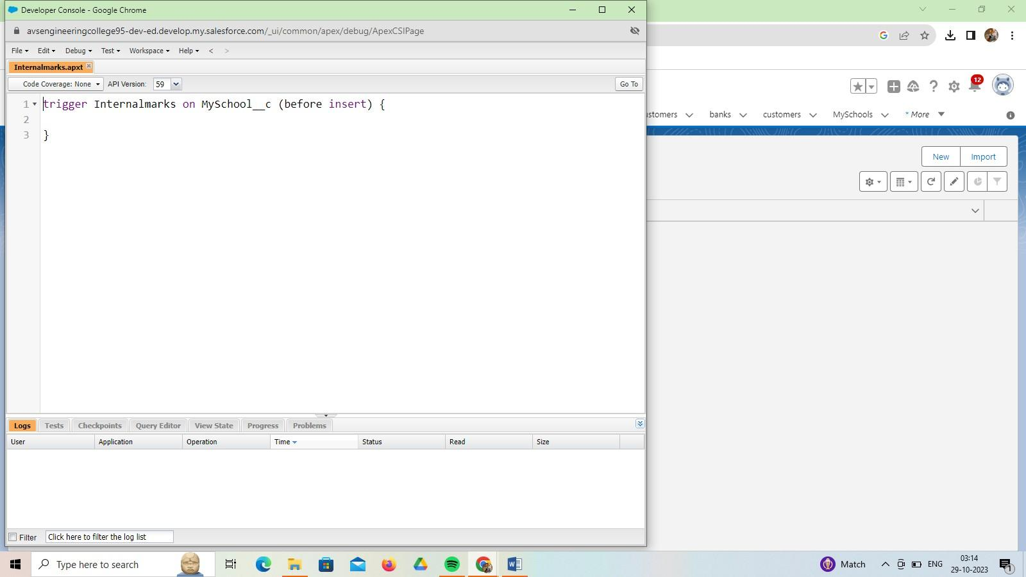

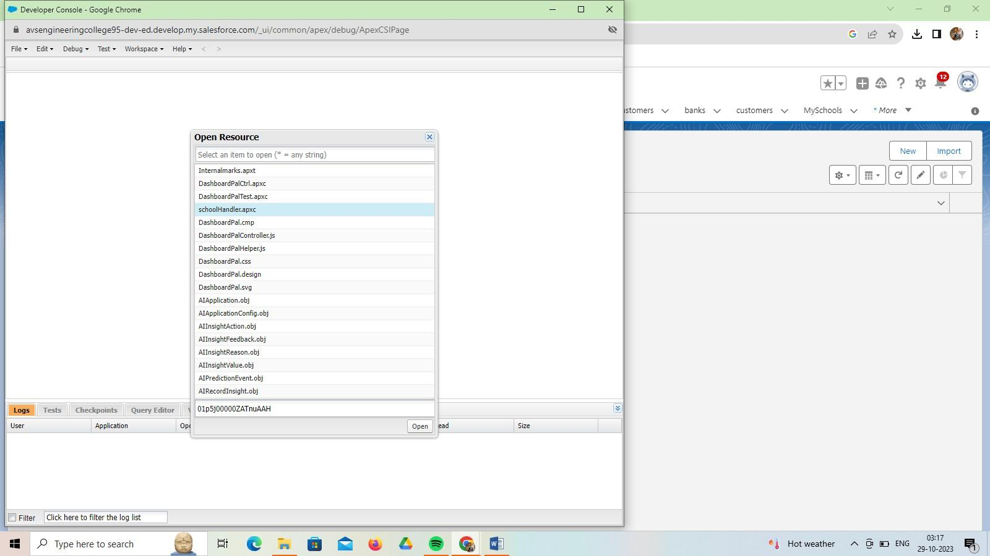

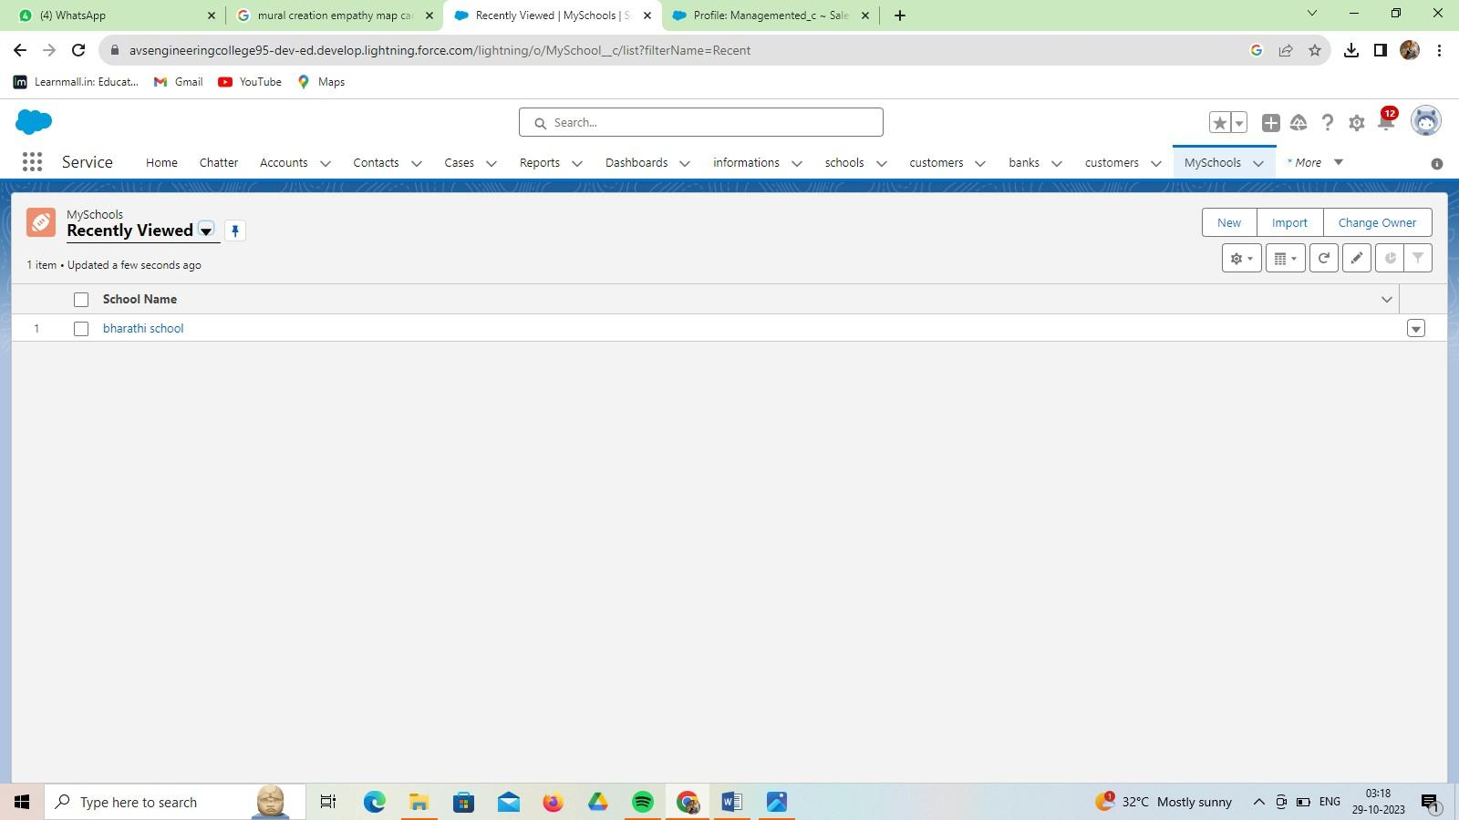

* 1. **Flow**

# CHAPTER-4 AUTOMATION

The last business rule functionality to implement before testing your application is a rule to set the Out-of-State checkbox field on the Travel Approval object if out- of-state travel has been chosen. Salesforce offers workflow capabilities that provide a declarative, drag-and-drop design environment to build our business process logic.

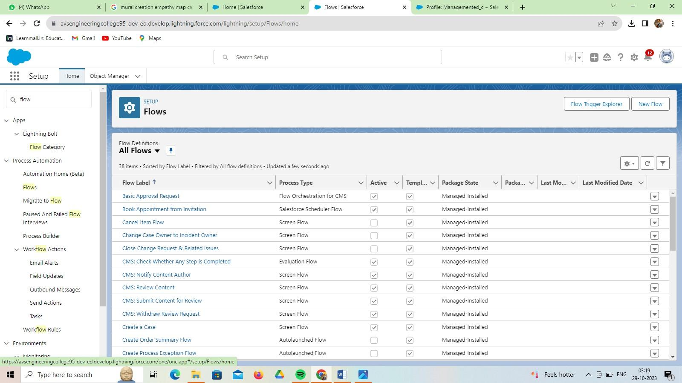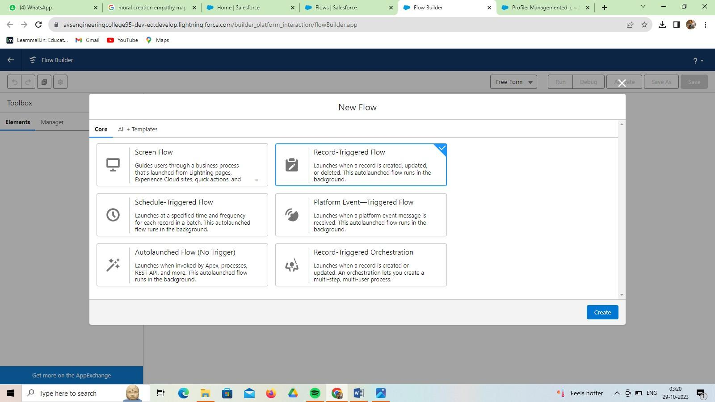

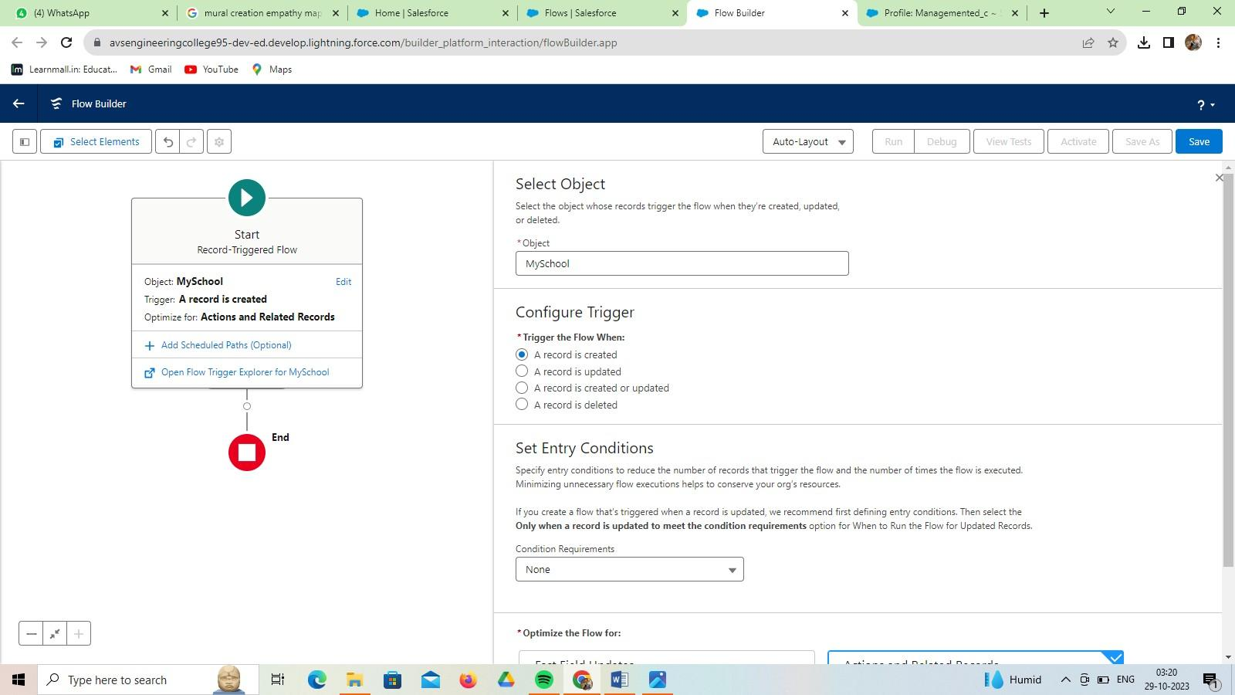

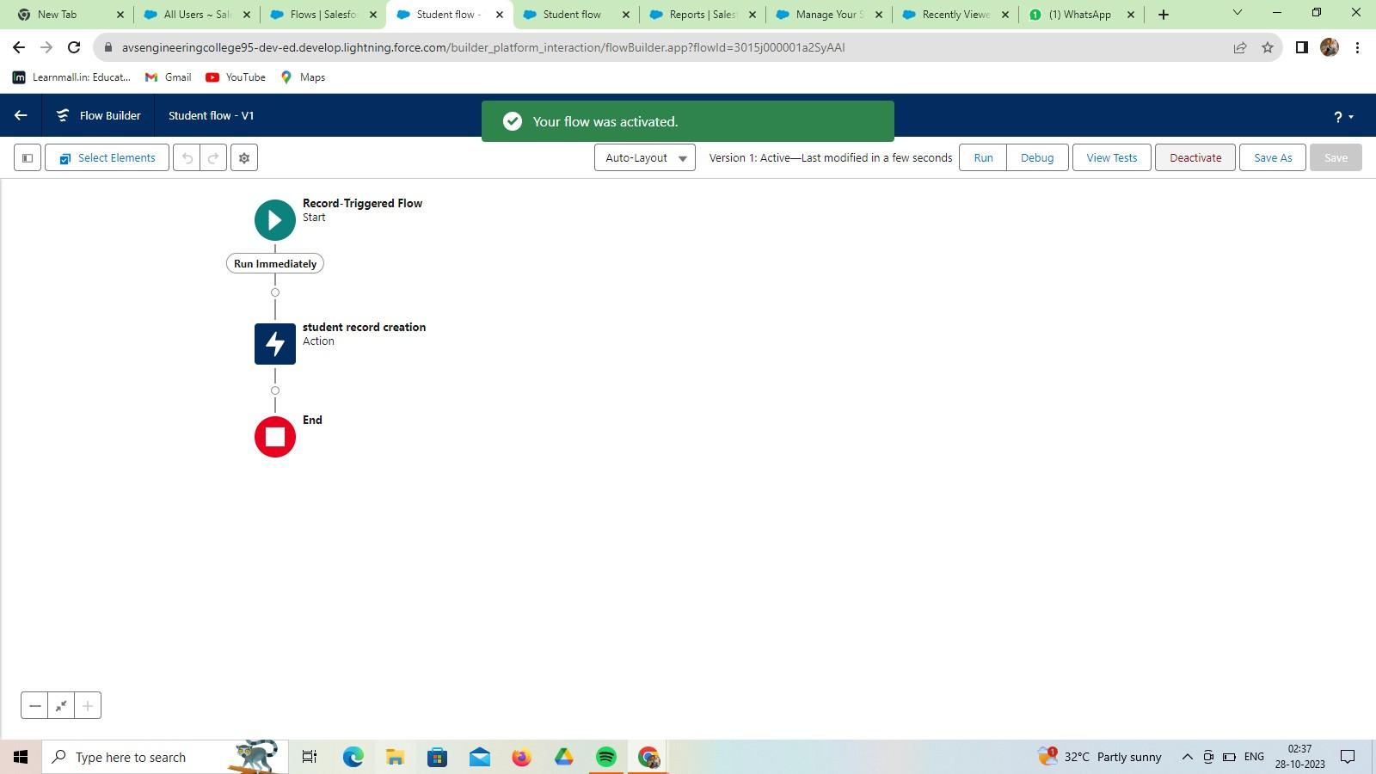

* 1. **Reports**

# CHAPTER-5 REPORTS & DASHBOARD

A Salesforce report is a list of data generated based on filter criteria. Salesforce Reports helped us predict trends and gives us the advantage to increase profits. The report builder provides a drag-and-drop interface to easily build and customize your reports.

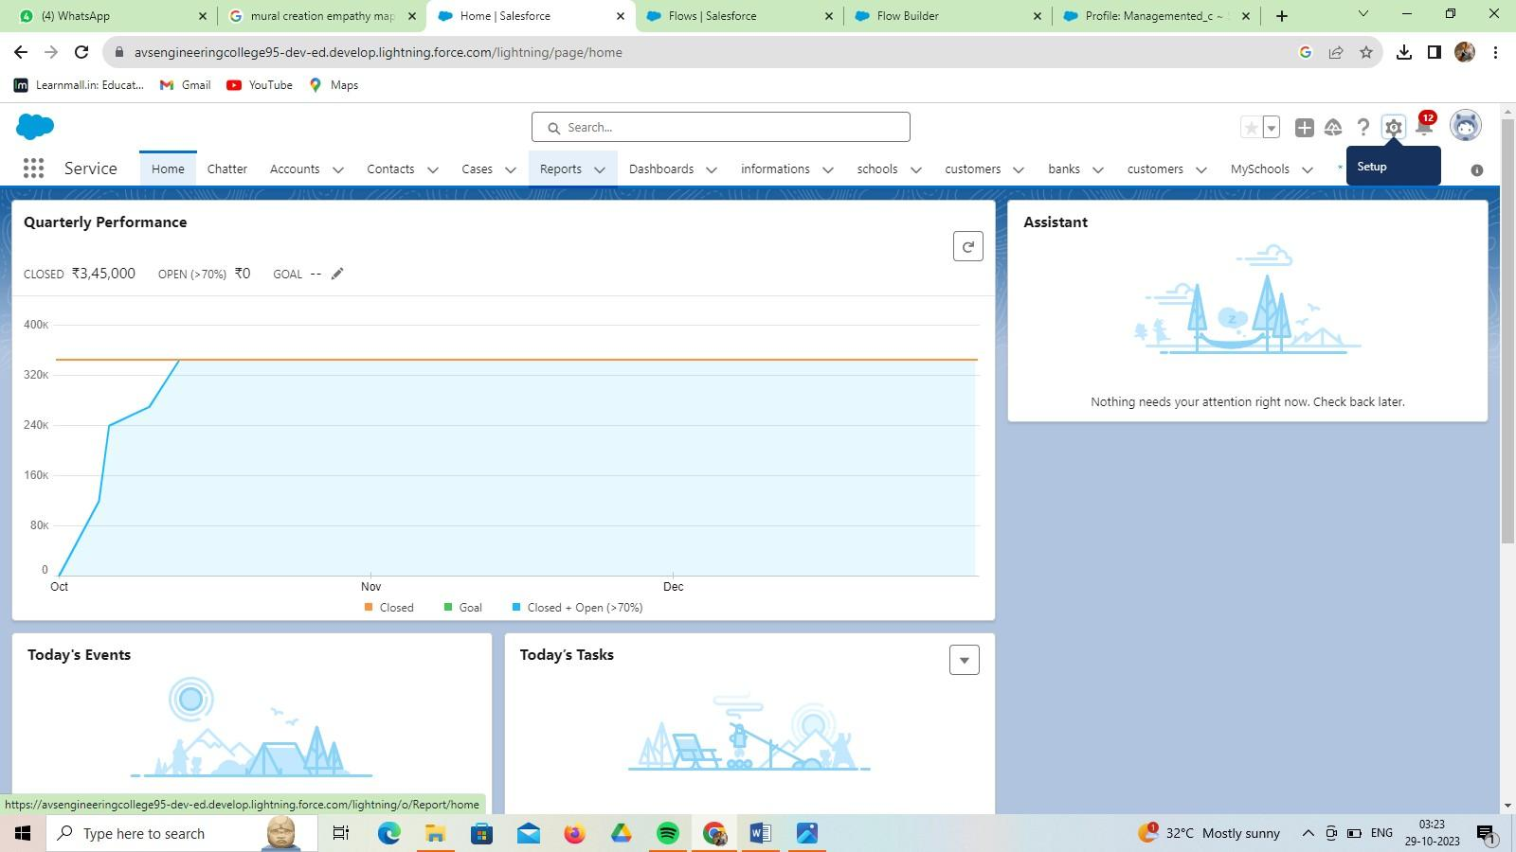

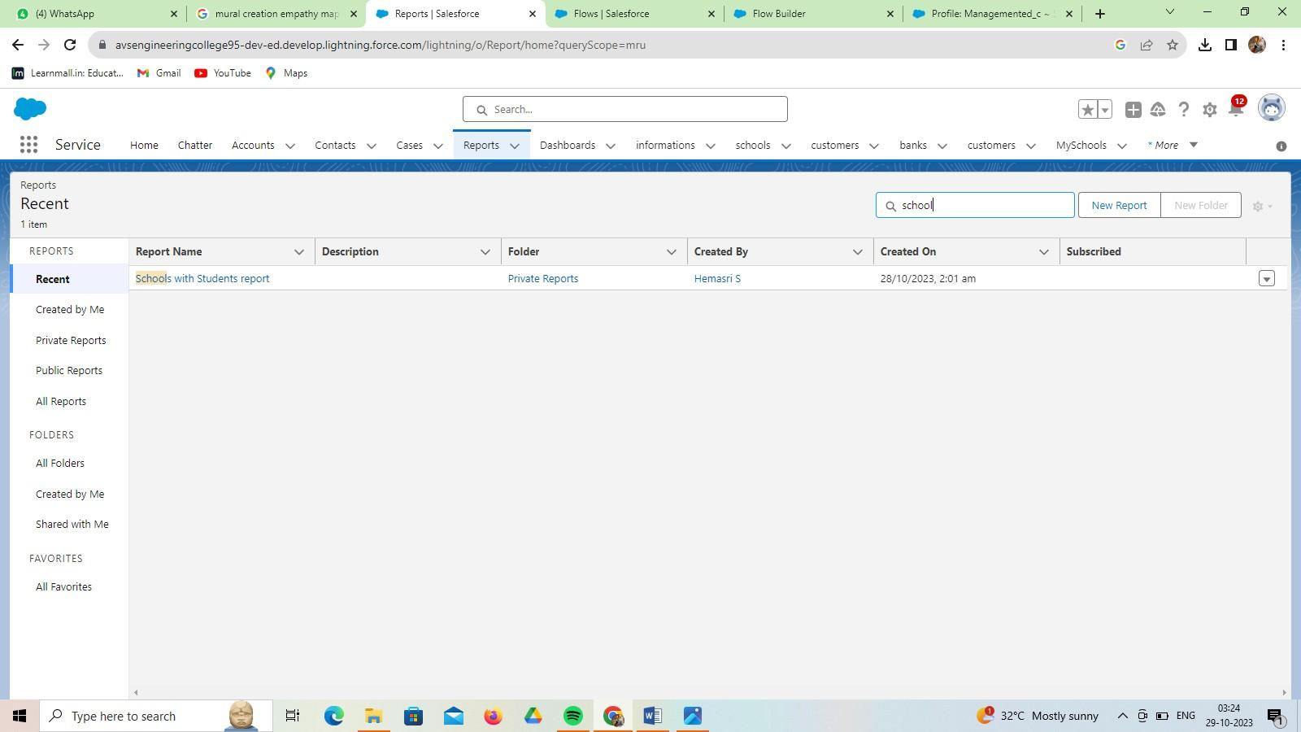

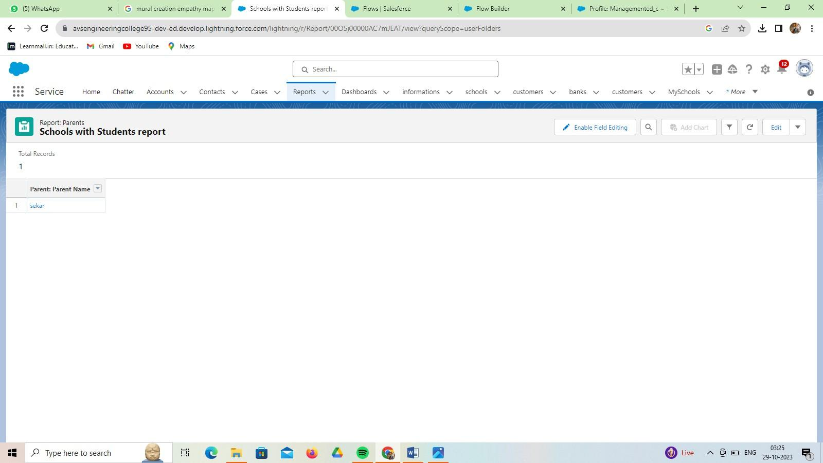

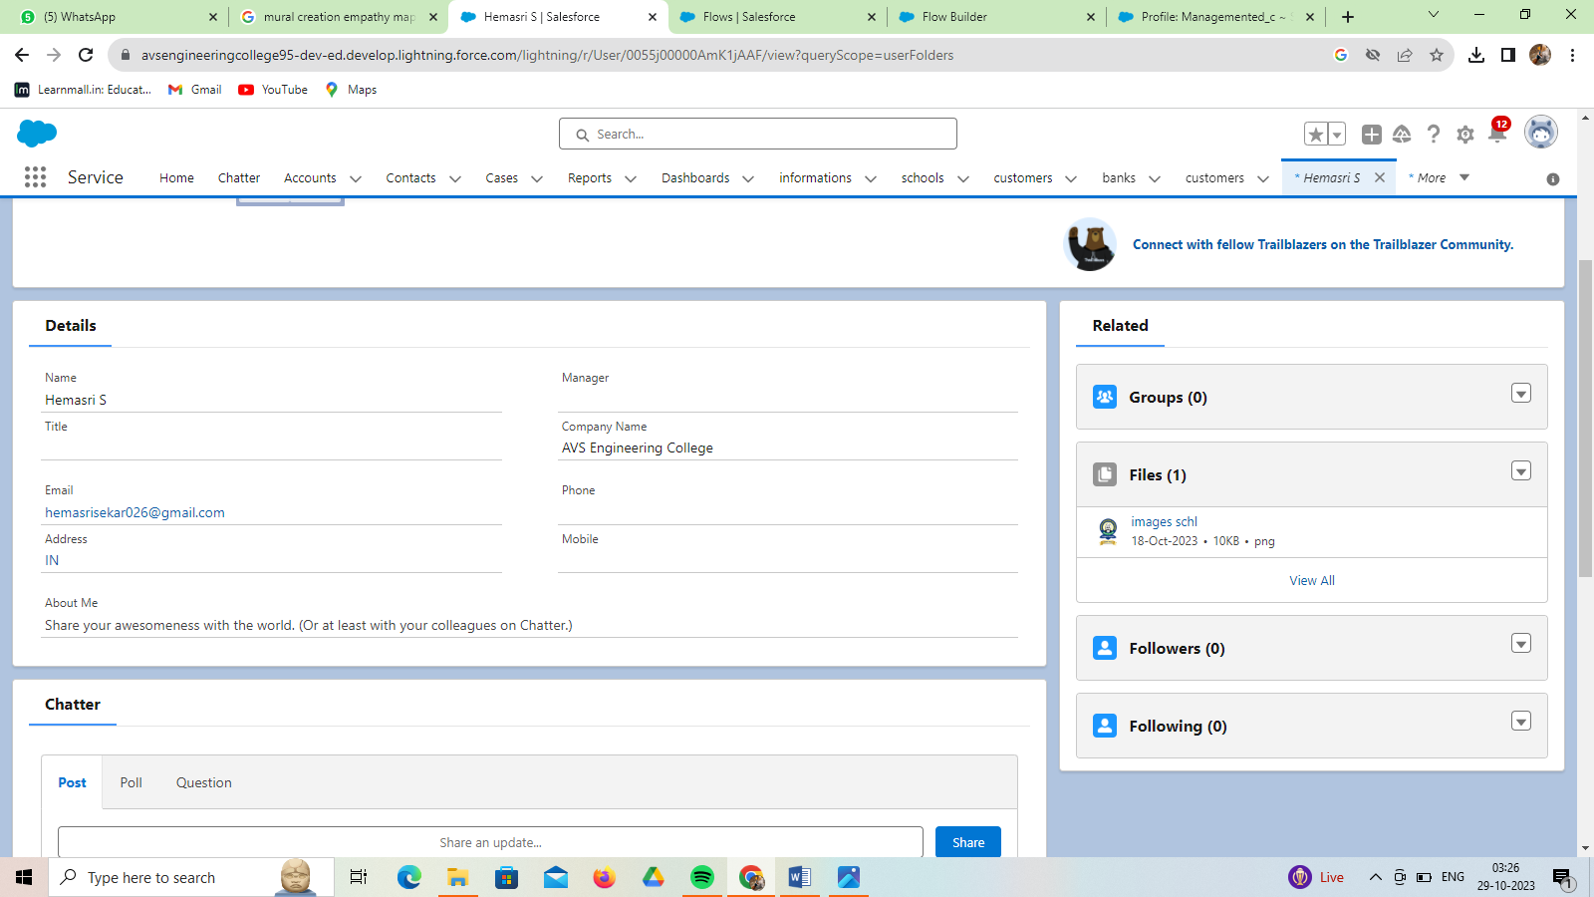

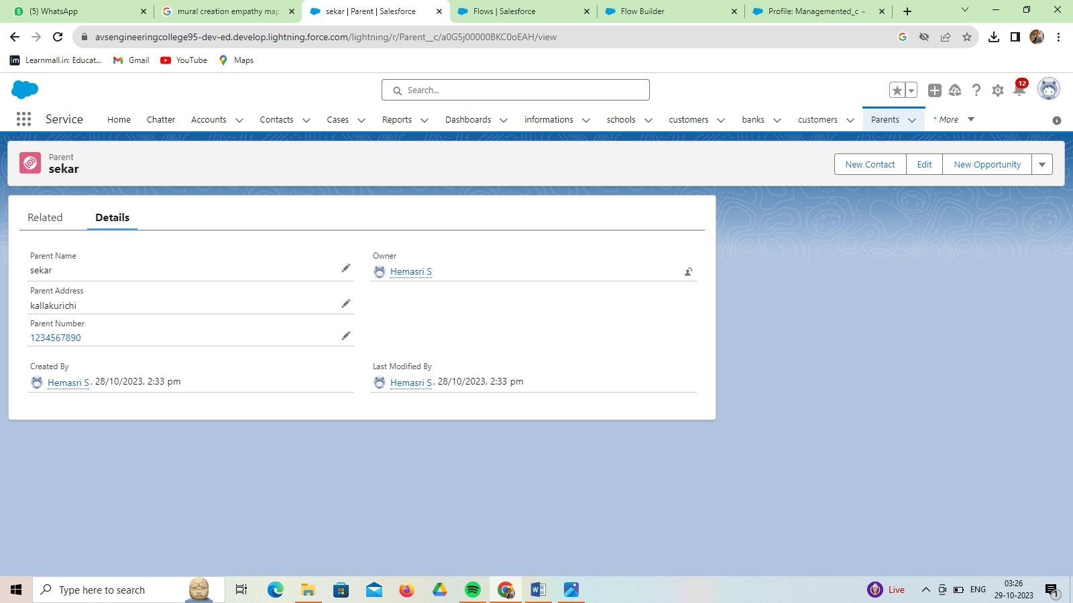

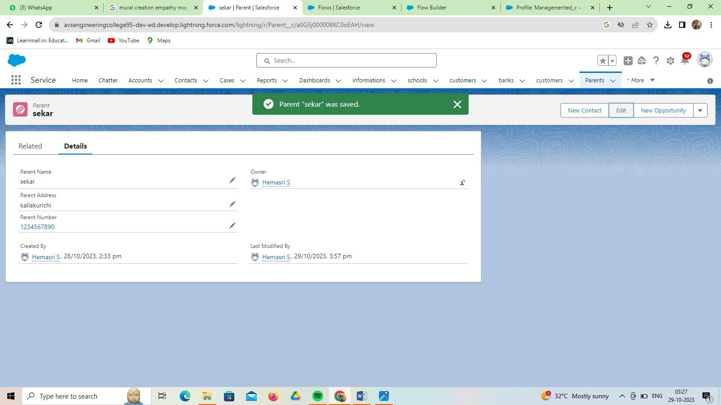

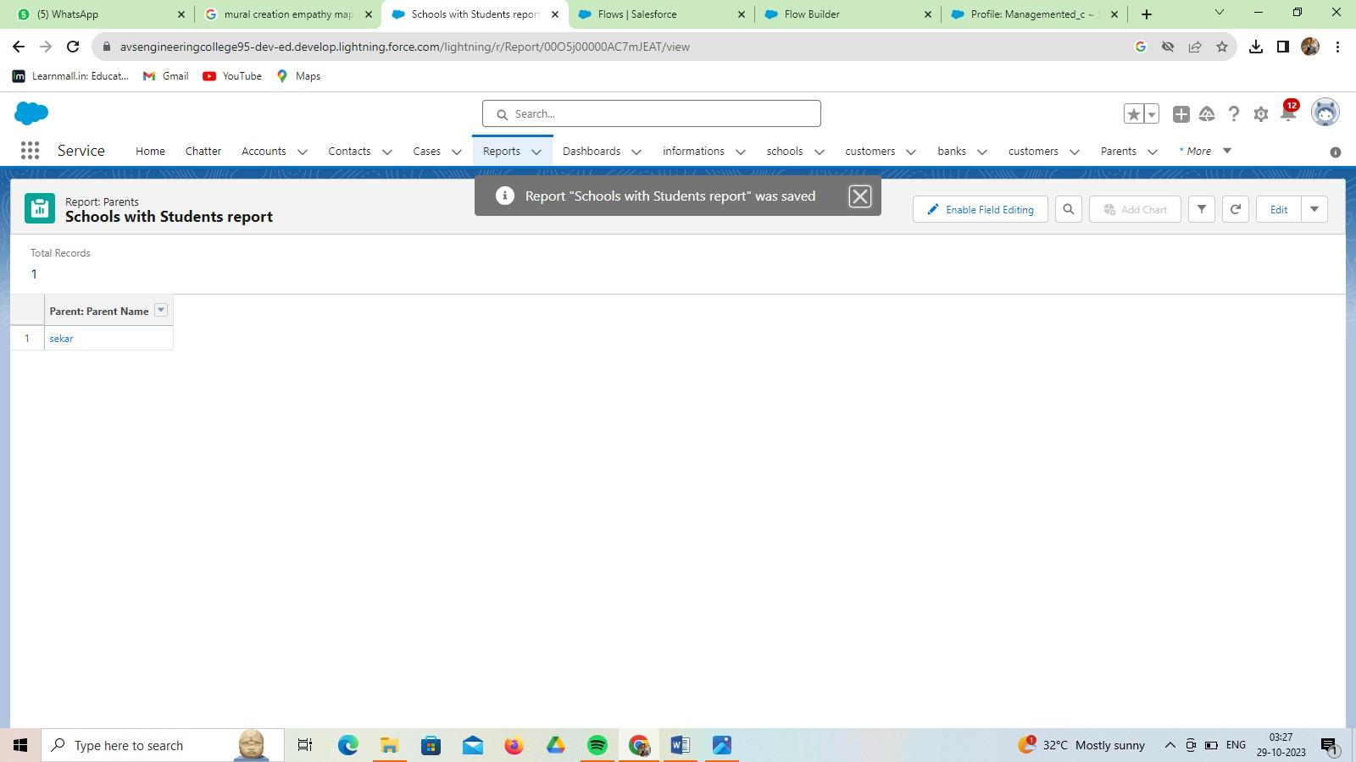

**View Report**

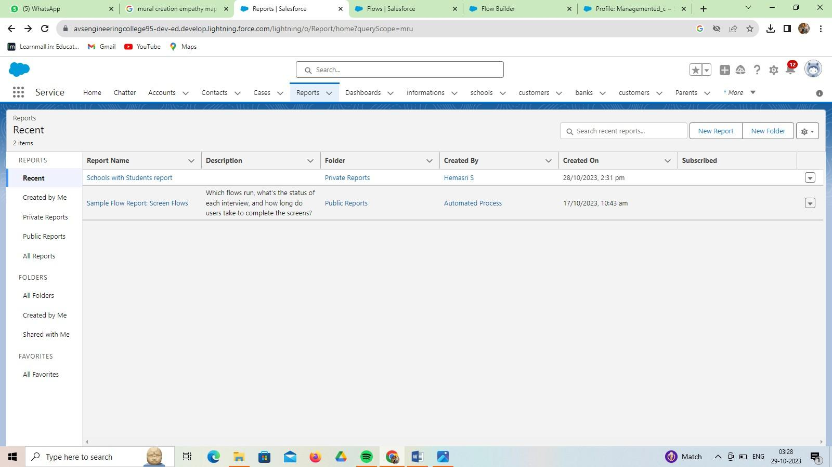

* 1. **Dashboard**

A dashboard provides an interactive visual display of key metrics and trends. Multiple dashboard components can be shown together on a single dashboard layout, creating rich visual displays of multiple reports that have a common theme.

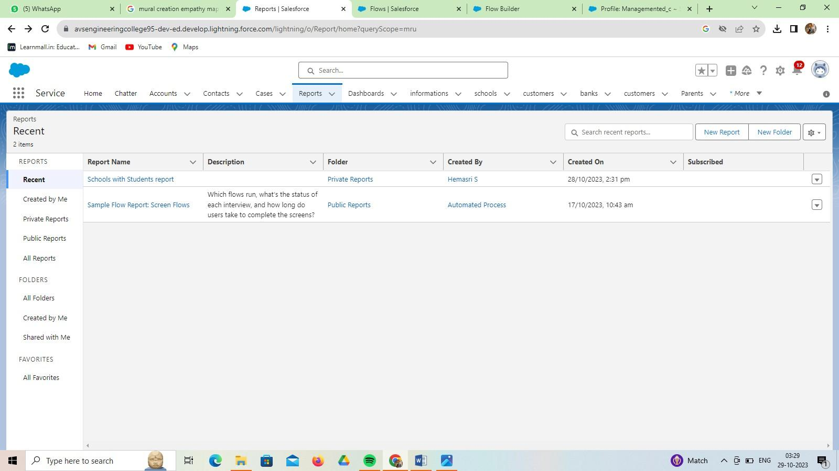

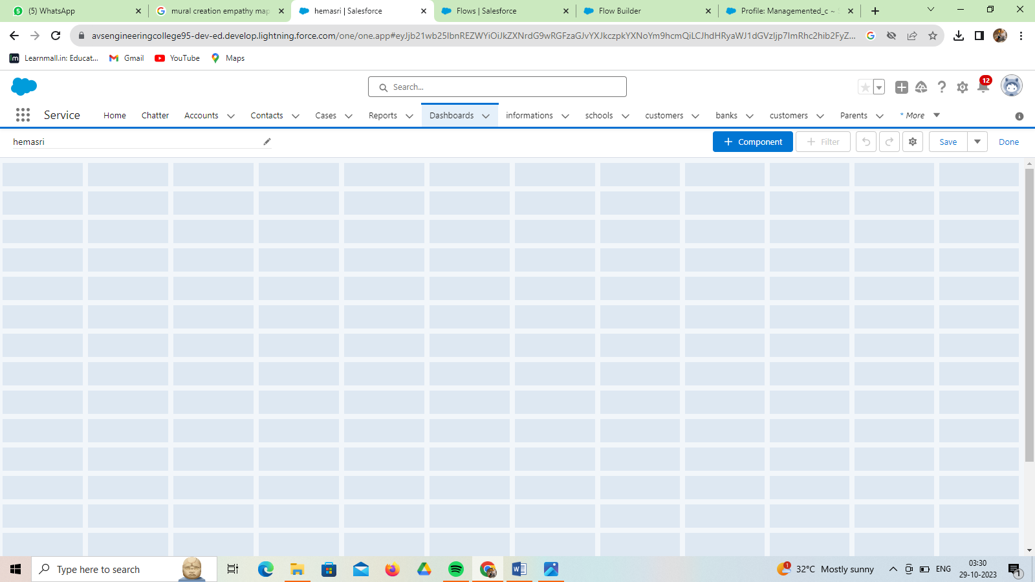

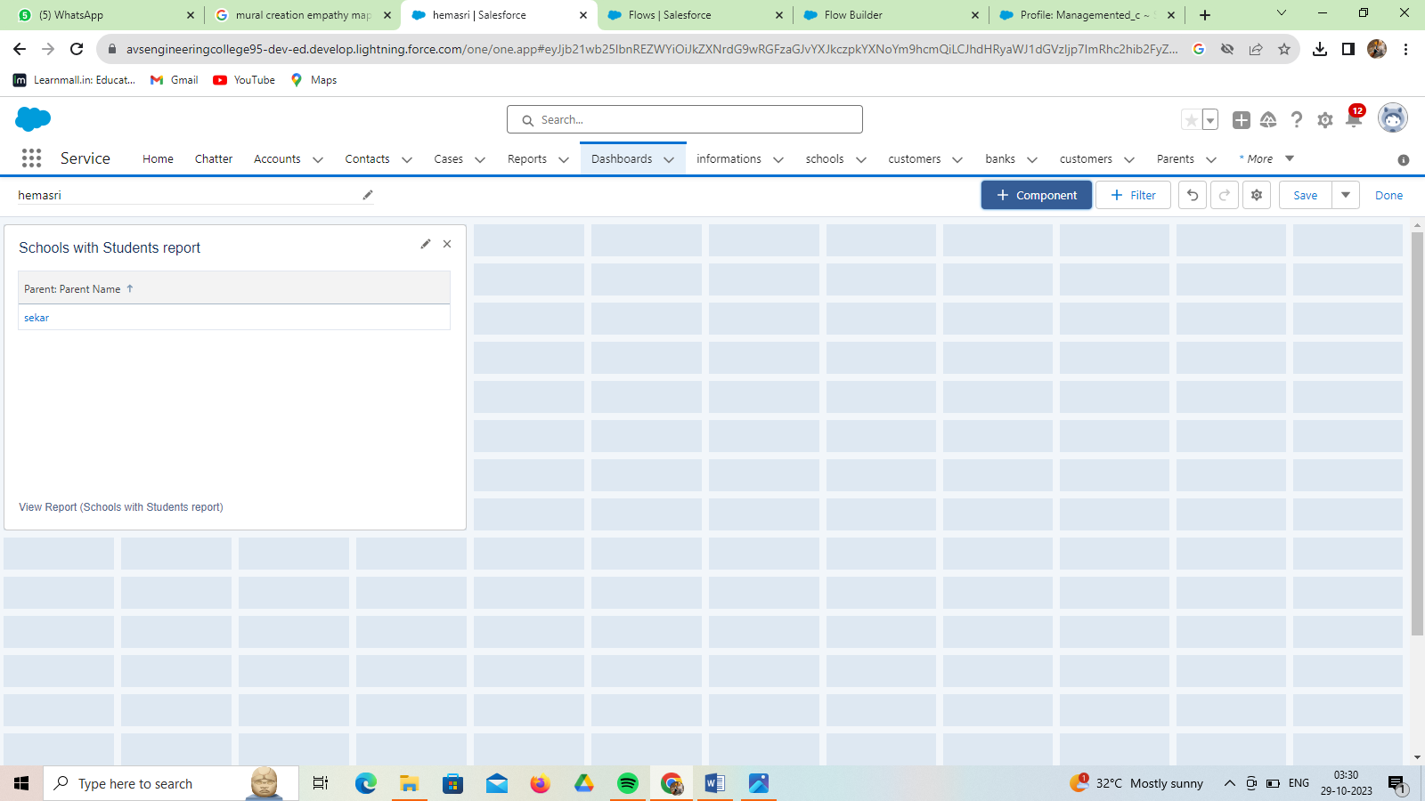

**View Dashboard**

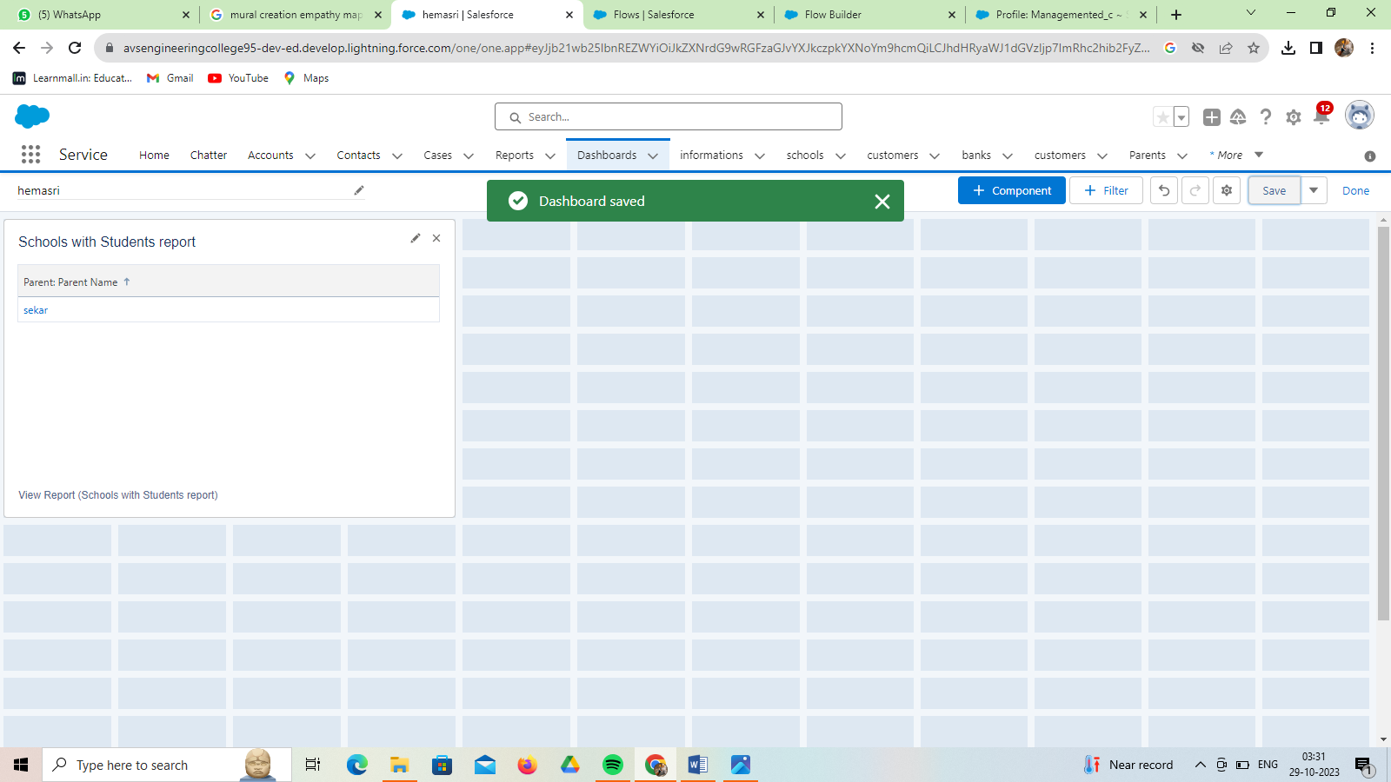

# CHAPTER-6 CONCLUSION

An effective conclusion brings the reader back to the main point, reminding the reader of the purpose of the essay. However, avoid repeating the thesis verbatim. Paraphrase your argument slightly while still preserving the primary point.

Briefly restates the main points of the writing and makes sense of any results that were obtained. To write a good conclusion, you can keep these points in mind the points made in the body of the text. Try to write these in a different way from how they were written in the body.

In all the school management system is bringing a great difference in the lives of students, teachers, parents, and the admin. Good management offers better productivity and hence more progress towards development.

School management software is an essential tool for educational institutions. It helps to streamline administrative tasks, improve communication, and enhance overall efficiency.

The “SCHOOL MANAGEMENT SYSTEM” deals with all kind of student details, academic related reports, curriculum, batch details and other resource related details too.

This creative problem solving is accomplished through four functions of management: planning, organizing, leading and controlling.

**GitHub:**

# CHAPTER-7 PROJECT DEMONSTRATION

[**https://github.com/S33HEMASRI/Salesforce**](https://github.com/S33HEMASRI/Salesforce)

**Demo Link:**

https://drive.google.com/file/d/1TYUas7mx93YVqT8ekIZOis6gFYJwDYBR/view

?usp=sharing